

|  |
| --- |
| **FPT UNIVERSITY** |
| Capstone Project Document  Report 3  Project Management Plan |
| |  |  |  |  |  |  |  |  |  |  |  | | --- | --- | --- | --- | --- | --- | --- | --- | --- | --- | --- | | |  |  | | --- | --- | | **Group 18** | | | **Group Members** | Đào Bảo Long – Team Leader – SE60690  Lê Phúc Lữ – Team Member – 60563  Nguyễn Thanh Tùng – Team Member – SE60609  Nguyễn Tấn Đức – Team Member – SE60660 | | **Supervisor** | Nguyễn Trọng Tài | | **Ext Supervisor** | N/A | | **Capstone Project Code** | i-Deliver |   Build a Web Application  for manages all activities of  delivery service system by coach. | |
|  |
|  |
| Hồ Chí Minh City, January 2014 |

|  |
| --- |
| *This page is intentionally left blank* |



# Software Requirement Specifications (SRS)



## User Requirement Specification

The system should allow 4 types of actors, namely Guest, Customer, Staff, and System Administrator, and an abstract actor named Logged User, to interact with. Each of these types of user is granted a set of functions as specified below.

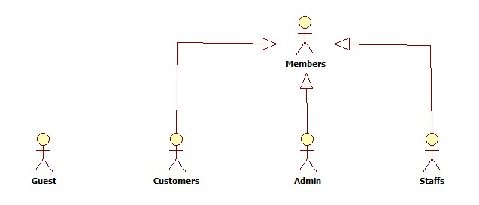

Diagram . Actor overview diagram



### Guest Requirements

A guest is an unauthenticated user of the website. He or she can:

* Log in with his authorized account;
* Register a new account;
* View, search for, and filter routes by a number of criteria that suit his or her needs;
* View details of an arbitrary routes.

### Logged User Requirements

A logged user is an authenticated user of the website (e.g., a user who logged on to the system with a valid username and password). They can:

* Log out;
* Change their own password;
* View and update their account details.

Note that that this actor is an abstract one and does not represent a real actor in practice.

### Customer Requirements

A Customer is a logged user (see 3.1.2. Logged User Requirement) and is given all the functions of a logged user. In addition, he or she is granted all the functions of a guest (see 3.1.1. Guest Requirement) except for the Log in and Register functions. A Customer also has his or her own set of functions:

* Create and submit the goods delivery requests;
* Cancel unwanted requests if they weren’t paid or approved;
* Edit submitted delivery information in a limit duration;
* Leave reviews about the service;
* Rate hotels by multiple criteria;
* Tracking for package (when the package left station, time left to be delivered, …);
* Make an online payment via third-party service.

### System Administrator Requirements

A System Administrator is a logged user (see 3.1.2. Logged User Requirement) and is given all the functions of a logged user. In addition, a system Administrator also has his or her own set of functions:

* Manage Staff accounts;
* Add more System Administrator accounts;
* Manage fee value and calculating formula;
* Statistics: get data about revenue, performance.

### Staff Requirements

A Staff is a logged user (see 3.1.2. Logged User Requirement) and is given all the functions of a logged user. In addition, a system Administrator also has his or her own set of functions:

* Manage all requests: approve, reject online requests, create new, edit and cancel offline requests;
* Manage all related information about routes, stations, trips and coaches;
* Arrange and schedule for packages delivery;
* Searching for information about requests, routes, stations, trips and coaches;
* Manage comments and rating: delete violated comments and clear spam rating;
* Statistics: get data about revenue, performance.

## System Requirement Specification (Specific Requirements)



### External Interface Requirements



#### User Interfaces

The i-Deliver website should adopt an attractive and user-friendly interface so that the users of the system can get a good experience browsing the site.

The pages should be well linked together to promote seamless navigation between them. The instructions should be specific and suggestive, so that the users will not be confused about what to do next.

Client postbacks should be limited wherever possible, in order to boost performance and ease of use.

Vietnamese should be the official language of the website as its target customers are mainly Vietnamese people. Vietnam Dong should be the official currency. Moreover, all other localizable information, such as date and time, should be Vietnamese-styled.

#### Hardware Interfaces

The i-Deliver website can be reached by personal computers that support Internet connection and web browsers. In order to get the best experience, the following conditions should be satisfied:

* 50 Kbps Internet connection or faster;
* 1 gigahertz (GHz) processor or faster;
* 512 megabytes (MB) RAM or more;

#### Software Interfaces

The software listed below is needed for the system to operate normally:

|  |  |  |  |
| --- | --- | --- | --- |
| **Software Name** | **Version** | **Cost** | **Provider** |
| Web Browser   * Internet Explorer * Google Chrome * Mozilla Firefox * Safari * Opera | 7.0 or higher | Free  Free  Free  Free  Free | Microsoft  Google  Mozilla  Apple  Opera |
| SQL Server Express | 10.0 | Free | Microsoft |
| .NET Framework | 4.5 | Free | Microsoft |
| IIS Express | 8 | Free | Microsoft |

### Main flow overviews

There are two main flows in the system as specified below.



#### Flow 1: Customers make goods delivery request

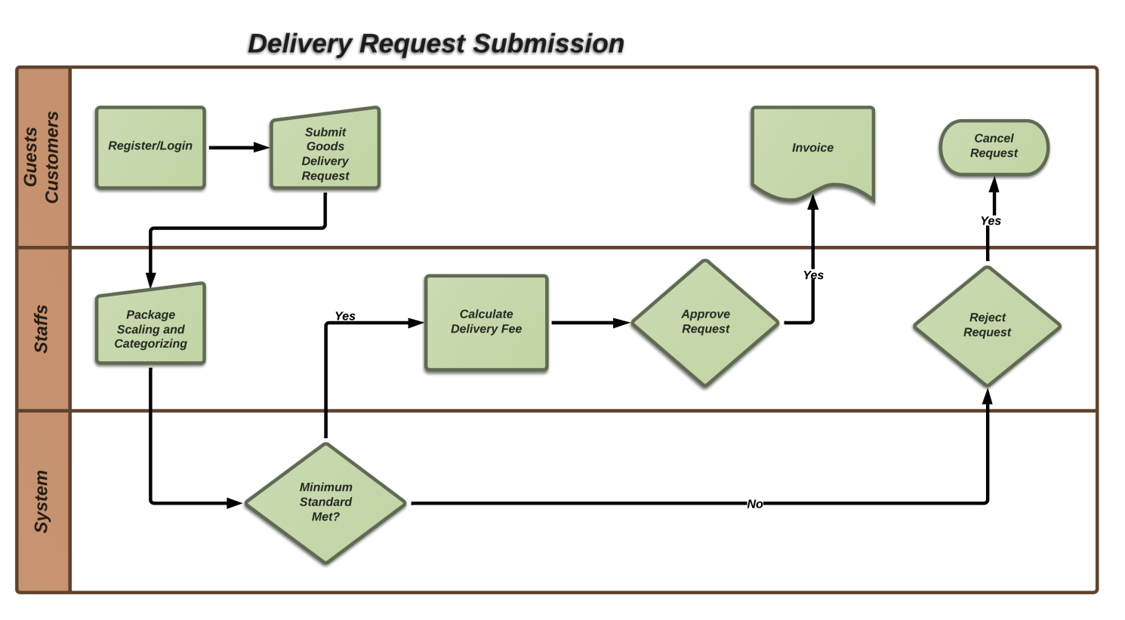

Figure . Customer make goods delivery request

The flows *Customer make goods delivery request* include the followings steps:

1. The customer login to the i-Deliver website (registration is required for guest);
2. The customer provides necessary deliver information (receiver address, detail contact, package weight and size, type of goods) to make a request; they can make a payment online via third-party service or the receiver will pay for delivery fee;
3. The staff re-scaling and categorizing package then confirm provided information to system to check package requirements and calculate delivery fee;
4. The staff approve request then make an invoice for customer if their package meet delivery standards, or they will reject request and return package to customer if not.

#### Flow 2: Staffs manage and scheduling for package delivery

The flow *Staff opens a hotel in the system* include the followings steps:

1. The Staff completes basic information of their hotel and makes a request to the system Administrator;
2. The hotel opening request is notified to the system Administrators;
3. The system Administrator check the validity of the hotel and approves of the hotel opening request;
4. The Staff continues to add images, room types, features for their hotel;
5. The Staff specifies prices and daily available statuses for each room. Until this step, their hotel is searchable, filterable, and can be booked on the I-DELIVER website;
6. The Staff installs a Facebook application for the Facebook page of their hotel (If there is no Facebook page for the hotel, the Staff must manually create one on Facebook).



Figure . Staff opens a hotel in the system

### System Features



#### Overall Use Case Diagram

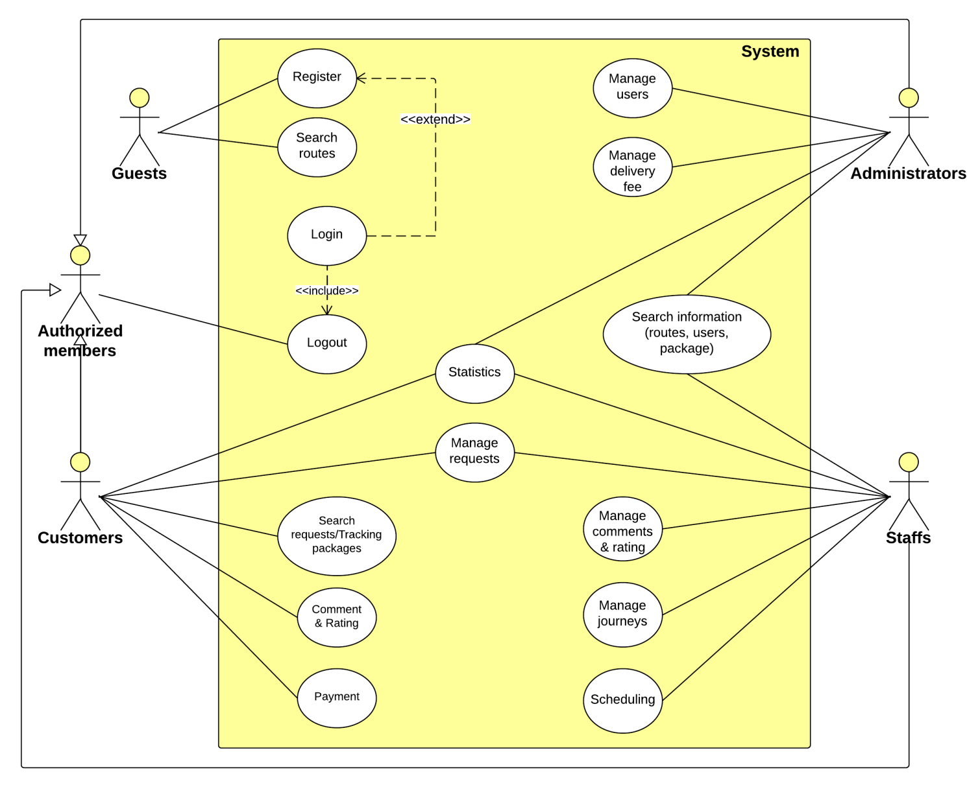

Diagram . Use case diagram

Note that only important and business-related use cases are described in details in the section below.

#### « Guest » Register

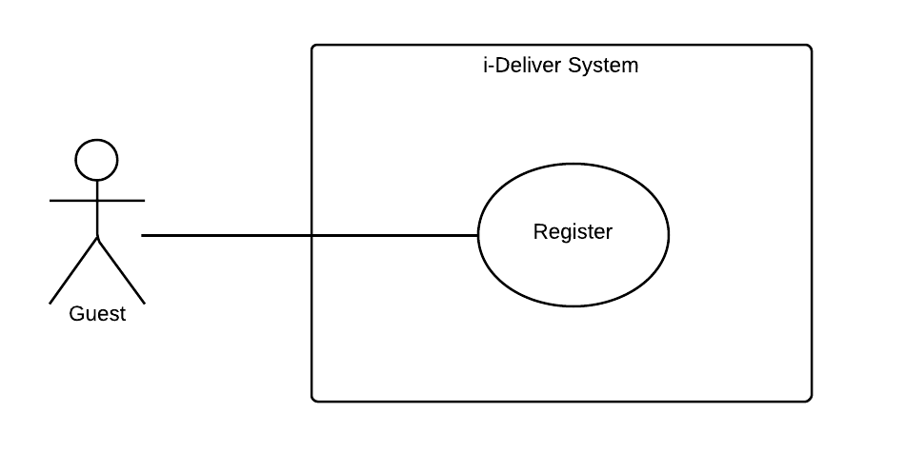

|  |  |  |  |  |
| --- | --- | --- | --- | --- |
| **– SPECIFICATION** | | | | |
| **Use-case No.** | UC002 | **Use-case Version** | | 1.0 |
| **Use-case Name** | Register | | | |
| **Author** | DucNTSE60660 | | | |
| **Date** | 07/02/2014 | **Priority** | Normal | |
| **Actor:** Guest  **Summary:**  This use case help guest to create an account in the system.  **Goal:**  Help Guest can have an account in the system.  **Triggers:**  Guest clicks on “Đăng Kí”.  **Preconditions:**  Guest needs an account to login in to the system in other to have more authorization in the system.  **Post Conditions:**  *On success:* A new account is created in the system. This account is user account type.  *On failure:* Show error message describe invalid fields, ask guest enter again or ask guest register again.  **Main Success Scenario:**   |  |  |  | | --- | --- | --- | | **Step** | **User Action** | **System Response** | | 1. | Guest clicks on “Đăng Kí” |  | | 2. |  | Display “Register” screen with text box for Guest to type all necessary info for creating new account. | | 3. | Guest inputs all required fields. |  | | 4. |  | Validate all input data. Send invalid message (if have). | | 5. | Correct all invalid fields (if have). |  | | 6. | Guest clicks on “Đồng Ý” button. |  | | 7. |  | System creates new account for guest. | | 8. |  | Redirect to Login page. |   **Alternative Scenario:**   |  |  |  |  | | --- | --- | --- | --- | | **No** | **Step** | **User Action** | **System Response** | | 1. | 1. |  |  | | 2. |  |  | | 2. | 1. |  |  | | 2. |  |  | | 3. | 1. |  |  | | 2. |  |  | | 3. | 1. |  |  | | 2. |  |  | | 4. | 1. |  |  | | 2. |  |  |   **Exceptions:**   |  |  |  | | --- | --- | --- | | **No** | **User Action** | **System Response** | | 1. |  |  | | 2. |  |  | | 3. |  |  | | 4. |  |  | | 5. |  |  | | 6. |  |  | | 7. |  |  | | 8. |  |  |   **Relationships:**  “Check room prices and availability” use case  **Business Rules:**   |  |  | | --- | --- | | **No** | **Business Rule Description** | | 1. | Guest must enter all required fields before submitting. | | 2. | Each registering, guest can create one account in the system. | | 3. | Each account in the system is distinguished by email address which assumes as username. | | 4. | When email fields of the new account are as same as the existing ones, the system will show invalid message. | | | | | |

#### « Guest, Customer » Search information

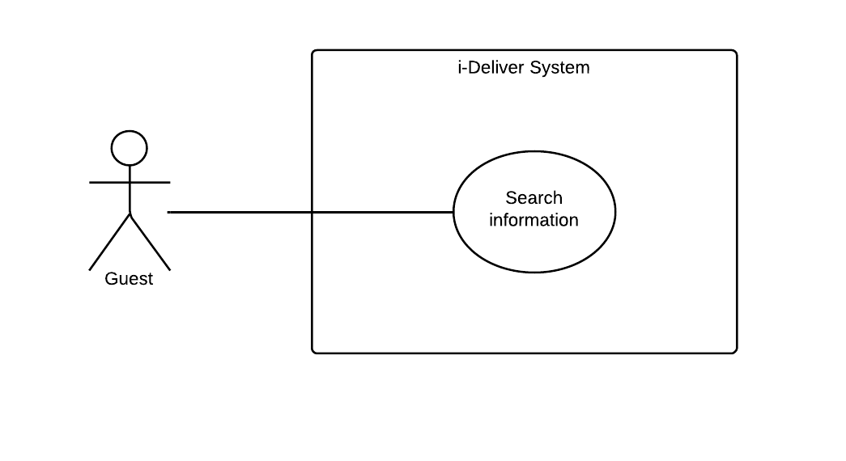

|  |  |  |  |  |
| --- | --- | --- | --- | --- |
| **– SPECIFICATION** | | | | |
| **Use-case No.** | UC003 | **Use-case Version** | | 1.0 |
| **Use-case Name** | Search information | | | |
| **Author** | DucNTSE60660 | | | |
| **Date** | 07/02/2014 | **Priority** | Normal | |
| **Actor:** Guest, Customer  **Summary:**  This use case is about allowing guest and customer can search information about routes, trips, etc.  **Goal:**  Help guest and customer view the information in system.  **Triggers:**  Guest enters keyword and click “Tìm kiếm” button.  **Preconditions:**  N/A  **Post Conditions:**  *On success:* Guest and customer can view their needed information.  *On failure:* Show message “Không tìm thấy kết quả”.  **Main Success Scenario:**   |  |  |  | | --- | --- | --- | | **Step** | **User Action** | **System Response** | | 1. | Guest clicks on textbox search and enters search keyword and then click on “Tìm kiếm” button. |  | | 2. |  | Display a table with information that suitable with search keyword. | | 3. |  | System show not found message. (if have). | | 4. |  |  | | 5. |  |  | | 6. |  |  |   **Alternative Scenario:**   |  |  |  |  | | --- | --- | --- | --- | | **No** | **Step** | **User Action** | **System Response** | | 1. | 1. |  |  | | 2. |  |  | | 2. | 1. |  |  | | 2. |  |  | | 3. | 1. |  |  | | 2. |  |  | | 3. | 1. |  |  | | 2. |  |  | | 4. | 1. |  |  | | 2. |  |  |   **Exceptions:**   |  |  |  | | --- | --- | --- | | **No** | **User Action** | **System Response** | | 1. |  |  | | 2. |  |  | | 3. |  |  | | 4. |  |  | | 5. |  |  | | 6. |  |  | | 7. |  |  | | 8. |  |  |   **Relationships:**  “Check room prices and availability” use case  **Business Rules:**   |  |  | | --- | --- | | **No** | **Business Rule Description** | | 1. |  | | 2. |  | | 3. |  | | | | | |

#### « Customer » Post request

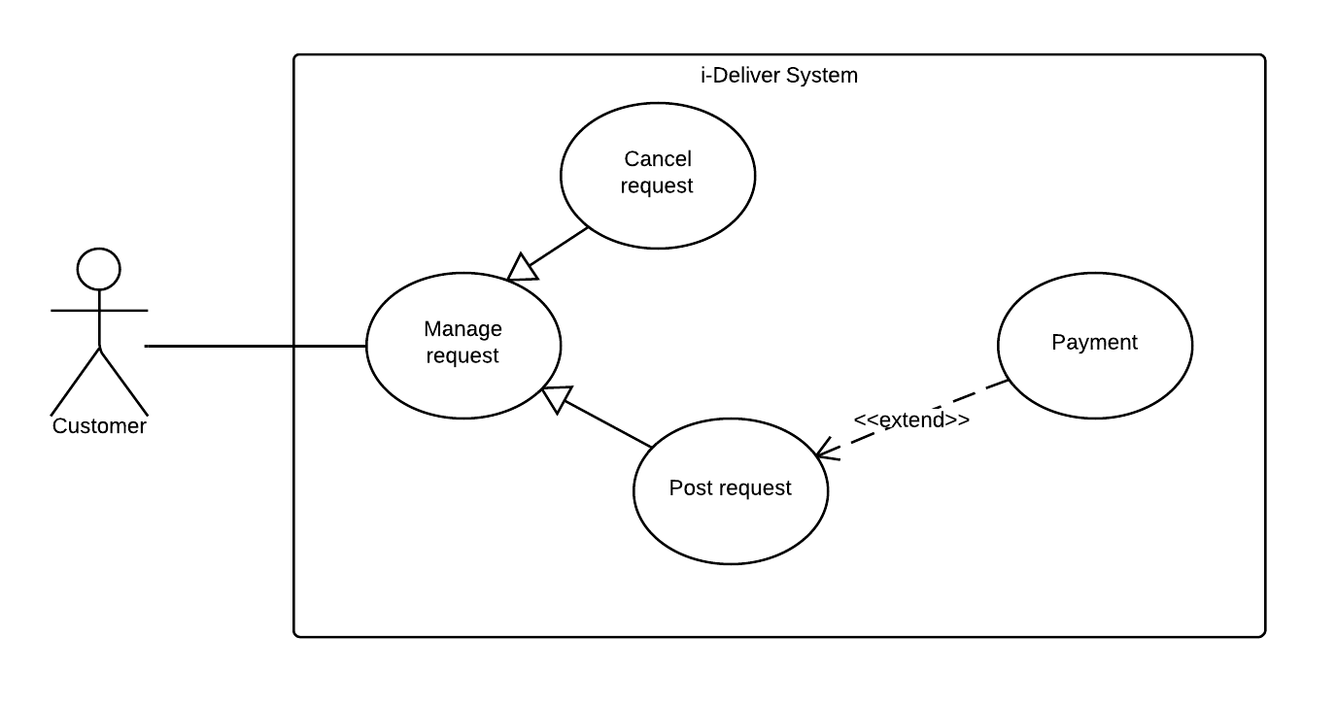

|  |  |  |  |  |
| --- | --- | --- | --- | --- |
| **– SPECIFICATION** | | | | |
| **Use-case No.** | UC004 | **Use-case Version** | | 1.0 |
| **Use-case Name** | Post request | | | |
| **Author** | DucNTSE60660 | | | |
| **Date** | 07/02/2014 | **Priority** | Normal | |
| **Actor:** Customer  **Summary:**  This use case is about allowing customer can post request to delivery their goods in the system.  **Goal:**  Customer can describe about their goods (size, weight, etc.), choose the place where to send the goods and get suggest fee from the system.  **Triggers:**  Customer click on “Gửi yêu cầu” link.  **Preconditions:**  Customer logon with customer role.  Customer post request for delivery goods.  **Post Conditions:**  *On success:* Request for transporting goods will be created.  *On failure:* Show message error.Ask customer request again.  **Main Success Scenario:**   |  |  |  | | --- | --- | --- | | **Step** | **User Action** | **System Response** | | 1. | Customer logon to the system with customer role. |  | | 2. | Customer clicks “Gửi yêu cầu” on menu. |  | | 3. |  | Display “Post request” screen with all textbox for customer to enter all necessary info for delivering goods. | | 4. | Customer enters all required fields. |  | | 5. |  | Validate all input data. Send invalid message (if have). | | 6. | Correct all invalid fields (if have). |  | | 7. | Customer click on” Xác nhận” button. |  | | 8. |  | System create new request for customer. |   **Alternative Scenario:**   |  |  |  |  | | --- | --- | --- | --- | | **No** | **Step** | **User Action** | **Systemm Response** | | 1. | 1. |  |  | | 2. |  |  | | 2. | 1. |  |  | | 2. |  |  | | 3. | 1. |  |  | | 2. |  |  | | 3. | 1. |  |  | | 2. |  |  | | 4. | 1. |  |  | | 2. |  |  |   **Exceptions:**   |  |  |  | | --- | --- | --- | | **No** | **User Action** | **System Response** | | 1. |  |  | | 2. |  |  | | 3. |  |  | | 4. |  |  | | 5. |  |  | | 6. |  |  | | 7. |  |  | | 8. |  |  |   **Relationships:**  “Check room prices and availability” use case  **Business Rules:**   |  |  | | --- | --- | | **No** | **Business Rule Description** | | 1. | Customer must login to use the system function. | | 2. | Customer must enter all required fields before submitting. | | 3. |  | | | | | |

#### « Customer » Edit request



|  |  |  |  |  |
| --- | --- | --- | --- | --- |
| **– SPECIFICATION** | | | | |
| **Use-case No.** | UC005 | **Use-case Version** | | 1.0 |
| **Use-case Name** | Edit request | | | |
| **Author** | DucNTSE60660 | | | |
| **Date** | 07/02/2014 | **Priority** | Normal | |
| **Actor:** Customer  **Summary:**  This use case is about allowing customer can change information of request.  **Goal:**  Customer can change wrong information, such as information of receiver, trips, etc.  Help for the transport of good become better.  **Triggers:**  N/A  **Preconditions:**  Customer login to the information with their role.  Customer must have previously submitted request.  **Post Conditions:**  *On success:* Request of information is updated.  *On failure:* Ask customer enter values again in wrong fields.  **Main Success Scenario:**   |  |  |  | | --- | --- | --- | | **Step** | **User Action** | **System Response** | | 1. | Customer login to the system with their role. |  | | 2. | Customer clicks “Yêu cầu đã gửi” link |  | | 3. |  | Show “All requests” screen. | | 4. | Customer choose a request that their want to edit. |  | | 5. |  | Show information of request screen. | | 6. | Customer changes value at allowed fields. |  | | 7. |  | Validate all input data. | | 8. |  | Show incorrect messages for each invalid value (if have). | | 9. | Customer correct all invalid value (if have). |  | | 10. | Customer clicks on “Xác nhận” button. |  | | 11. |  | New information of request is updated in database. | | 12. |  | Redirect to “All request” screen. |   **Alternative Scenario:**   |  |  |  |  | | --- | --- | --- | --- | | **No** | **Step** | **User Action** | **System Response** | | 1. | 1. |  |  | | 2. |  |  | | 2. | 1. |  |  | | 2. |  |  | | 3. | 1. |  |  | | 2. |  |  | | 3. | 1. |  |  | | 2. |  |  | | 4. | 1. |  |  | | 2. |  |  |   **Exceptions:**   |  |  |  | | --- | --- | --- | | **No** | **User Action** | **System Response** | | 1. |  |  | | 2. |  |  | | 3. |  |  | | 4. |  |  | | 5. |  |  | | 6. |  |  | | 7. |  |  | | 8. |  |  |   **Relationships:**  “Check room prices and availability” use case  **Business Rules:**   |  |  | | --- | --- | | **No** | **Business Rule Description** | | 1. | Customer must have previously submitted request. | | 2. |  | | 3. |  | | | | | |

#### « Customer » Cancel request



|  |  |  |  |  |
| --- | --- | --- | --- | --- |
| **– SPECIFICATION** | | | | |
| **Use-case No.** | UC006 | **Use-case Version** | | 1.0 |
| **Use-case Name** | Cancel request | | | |
| **Author** | DucNTSE60660 | | | |
| **Date** | 07/02/2014 | **Priority** | Normal | |
| **Actor:** Customer  **Summary:**  This use case is about allowing customer to cancel request for delivery goods.  **Goal:**  Cancel request for delivery goods.  **Triggers:**  N/A  **Preconditions:**  Customer login to the information with their role.  Customer must have previously submitted request.  **Post Conditions:**  *On success:* Request for delivery goods is removed.  *On failure:* N/A  **Main Success Scenario:**   |  |  |  | | --- | --- | --- | | **Step** | **User Action** | **System Response** | | 1. | Customer logon to the system with customer role. |  | | 2. | Customer clicks “Yêu cầu đã gửi” link |  | | 3. |  | Show “All requests” screen. | | 4. | Customer chooses a request and clicks on “Huỷ bỏ” button. |  | | 5. |  | Show message box to confirm. | | 2. | Customer chooses “Có” or “Không”. |  | | 3. |  | Redirect “All requests” screen. |   **Alternative Scenario:**   |  |  |  |  | | --- | --- | --- | --- | | **No** | **Step** | **User Action** | **System Response** | | 1. | 1. |  |  | | 2. |  |  | | 2. | 1. |  |  | | 2. |  |  | | 3. | 1. |  |  | | 2. |  |  | | 3. | 1. |  |  | | 2. |  |  | | 4. | 1. |  |  | | 2. |  |  |   **Exceptions:**   |  |  |  | | --- | --- | --- | | **No** | **User Action** | **System Response** | | 1. |  |  | | 2. |  |  | | 3. |  |  | | 4. |  |  | | 5. |  |  | | 6. |  |  | | 7. |  |  | | 8. |  |  |   **Relationships:**  “Check room prices and availability” use case  **Business Rules:**   |  |  | | --- | --- | | **No** | **Business Rule Description** | | 1. | Customer must have previously submitted request. | | 2. |  | | 3. |  | | | | | |

#### « Customer » Search request

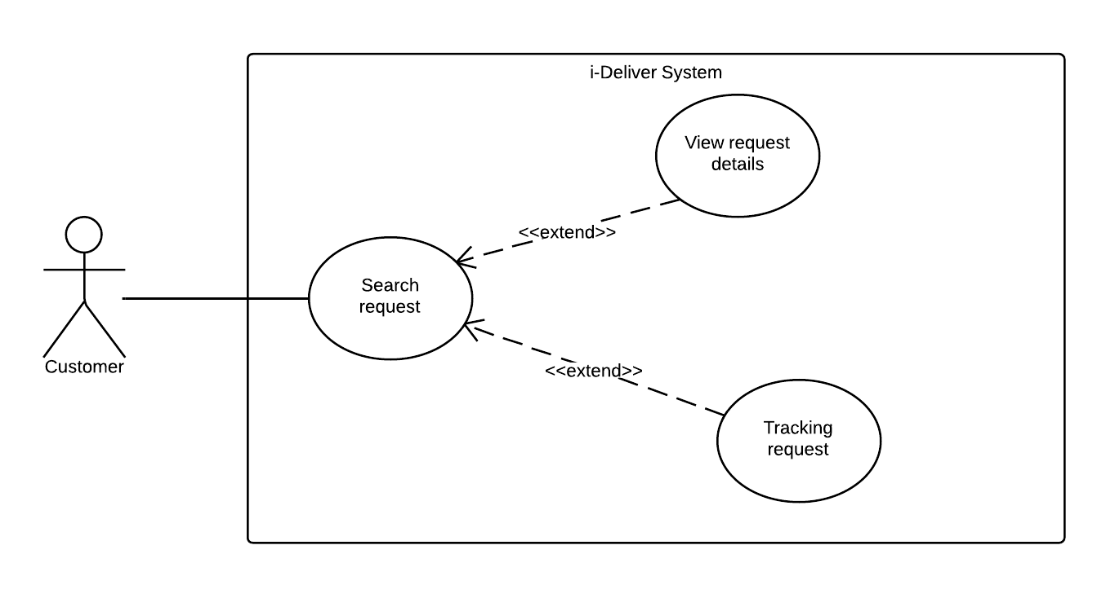

|  |  |  |  |  |
| --- | --- | --- | --- | --- |
| **– SPECIFICATION** | | | | |
| **Use-case No.** | UC007 | **Use-case Version** | | 1.0 |
| **Use-case Name** | Search request | | | |
| **Author** | DucNTSE60660 | | | |
| **Date** | 10/02/2014 | **Priority** | Normal | |
| **Actor:** Customer  **Summary:**  This use case is about allowing customer can search their request.  **Goal:**  Customer can search previously submitted request.  **Triggers:**  Guest enters keyword and click “Tìm kiếm” button.  **Preconditions:**  N/A  **Post Conditions:**  *On success:* Show a list of request suitable with search keyword.  *On failure:* Show message “Không tìm thấy kết quả”.  **Main Success Scenario:**   |  |  |  | | --- | --- | --- | | **Step** | **User Action** | **System Response** | | 1. |  |  | | 2. |  |  | | 3. |  |  | | 4. |  |  | | 5. |  |  | | 6. |  |  |   **Alternative Scenario:**   |  |  |  |  | | --- | --- | --- | --- | | **No** | **Step** | **User Action** | **System Response** | | 1. | 1. |  |  | | 2. |  |  | | 2. | 1. |  |  | | 2. |  |  | | 3. | 1. |  |  | | 2. |  |  | | 3. | 1. |  |  | | 2. |  |  | | 4. | 1. |  |  | | 2. |  |  |   **Exceptions:**   |  |  |  | | --- | --- | --- | | **No** | **User Action** | **System Response** | | 1. |  |  | | 2. |  |  | | 3. |  |  | | 4. |  |  | | 5. |  |  | | 6. |  |  | | 7. |  |  | | 8. |  |  |   **Relationships:**  “Check room prices and availability” use case  **Business Rules:**   |  |  | | --- | --- | | **No** | **Business Rule Description** | | 1. | Customer must have previously submitted request | | 2. |  | | 3. |  | | | | | |

#### « Customer » Tracking package



|  |  |  |  |  |
| --- | --- | --- | --- | --- |
| **– SPECIFICATION** | | | | |
| **Use-case No.** | UC008 | **Use-case Version** | | 1.0 |
| **Use-case Name** | Tracking package | | | |
| **Author** | DucNTSE60660 | | | |
| **Date** | 11/02/2014 | **Priority** | Normal | |
| **Actor:** Customer  **Summary:**  This use case allows customer can check amount of time that their package was sent.  **Goal:**  Help customer can track their package.  **Triggers:**  N/A  **Preconditions:**  Customer login to the system.  Customer must have previously submitted request and this request is pending.  **Post Conditions:**  *On success:*  *On failure:*  **Main Success Scenario:**   |  |  |  | | --- | --- | --- | | **Step** | **User Action** | **System Response** | | 1. |  |  | | 2. |  |  | | 3. |  |  | | 4. |  |  | | 5. |  |  | | 6. |  |  |   **Alternative Scenario:**   |  |  |  |  | | --- | --- | --- | --- | | **No** | **Step** | **User Action** | **System Response** | | 1. | 1. |  |  | | 2. |  |  | | 2. | 1. |  |  | | 2. |  |  | | 3. | 1. |  |  | | 2. |  |  | | 3. | 1. |  |  | | 2. |  |  | | 4. | 1. |  |  | | 2. |  |  |   **Exceptions:**   |  |  |  | | --- | --- | --- | | **No** | **User Action** | **System Response** | | 1. |  |  | | 2. |  |  | | 3. |  |  | | 4. |  |  | | 5. |  |  | | 6. |  |  | | 7. |  |  | | 8. |  |  |   **Relationships:**  “Check room prices and availability” use case  **Business Rules:**   |  |  | | --- | --- | | **No** | **Business Rule Description** | | 1. |  | | 2. |  | | 3. |  | | | | | |

#### « Customer » View request detail



|  |  |  |  |  |
| --- | --- | --- | --- | --- |
| **– SPECIFICATION** | | | | |
| **Use-case No.** | UC009 | **Use-case Version** | | 1.0 |
| **Use-case Name** | View request detail | | | |
| **Author** | DucNTSE60660 | | | |
| **Date** | 11/02/2014 | **Priority** | Normal | |
| **Actor:** Customer  **Summary:**  This usecase allows customer view all information of their request.  **Goal:**  View information of request.  **Triggers:**  Customer click on a request from list of requests.  **Preconditions:**  Customer must have previously submitted request.  Customer login to the system.  List of request page must be displayed.  **Post Conditions:**  *On success:* Show all information of request.  *On failure:* Show message error.  **Main Success Scenario:**   |  |  |  | | --- | --- | --- | | **Step** | **User Action** | **System Response** | | 1. |  |  | | 2. |  |  | | 3. |  |  | | 4. |  |  | | 5. |  |  | | 6. |  |  |   **Alternative Scenario:**   |  |  |  |  | | --- | --- | --- | --- | | **No** | **Step** | **User Action** | **System Response** | | 1. | 1. |  |  | | 2. |  |  | | 2. | 1. |  |  | | 2. |  |  | | 3. | 1. |  |  | | 2. |  |  | | 3. | 1. |  |  | | 2. |  |  | | 4. | 1. |  |  | | 2. |  |  |   **Exceptions:**   |  |  |  | | --- | --- | --- | | **No** | **User Action** | **System Response** | | 1. |  |  | | 2. |  |  | | 3. |  |  | | 4. |  |  | | 5. |  |  | | 6. |  |  | | 7. |  |  | | 8. |  |  |   **Relationships:**  “Check room prices and availability” use case  **Business Rules:**   |  |  | | --- | --- | | **No** | **Business Rule Description** | | 1. | Customer must have previously submitted request. | | 2. |  | | 3. |  | | | | | |

#### « Customer » Payment



|  |  |  |  |  |
| --- | --- | --- | --- | --- |
| **– SPECIFICATION** | | | | |
| **Use-case No.** | UC0010 | **Use-case Version** | | <1.0> |
| **Use-case Name** | Payment | | | |
| **Author** | DucNTSE60660 | | | |
| **Date** | 11/02/2014 | **Priority** | Normal | |
| **Actor:** Customer  **Summary:**  This use case allows customer can choose a way to payment (direct or online payment).  **Goal:**  Pay to use the service.  **Triggers:**  Customer click on “Thanh toán” button.  **Preconditions:**  Customer must login to the system.  Customer have unpaid request.  **Post Conditions:**  *On success:*  *On failure:*  **Main Success Scenario:**   |  |  |  | | --- | --- | --- | | **Step** | **User Action** | **System Response** | | 1. |  |  | | 2. |  |  | | 3. |  |  | | 4. |  |  | | 5. |  |  | | 6. |  |  |   **Alternative Scenario:**   |  |  |  |  | | --- | --- | --- | --- | | **No** | **Step** | **User Action** | **System Response** | | 1. | 1. |  |  | | 2. |  |  | | 2. | 1. |  |  | | 2. |  |  | | 3. | 1. |  |  | | 2. |  |  | | 3. | 1. |  |  | | 2. |  |  | | 4. | 1. |  |  | | 2. |  |  |   **Exceptions:**   |  |  |  | | --- | --- | --- | | **No** | **User Action** | **System Response** | | 1. |  |  | | 2. |  |  | | 3. |  |  | | 4. |  |  | | 5. |  |  | | 6. |  |  | | 7. |  |  | | 8. |  |  |   **Relationships:**  “Check room prices and availability” use case  **Business Rules:**   |  |  | | --- | --- | | **No** | **Business Rule Description** | | 1. |  | | 2. |  | | 3. |  | | | | | |

#### « Customer » Statistics

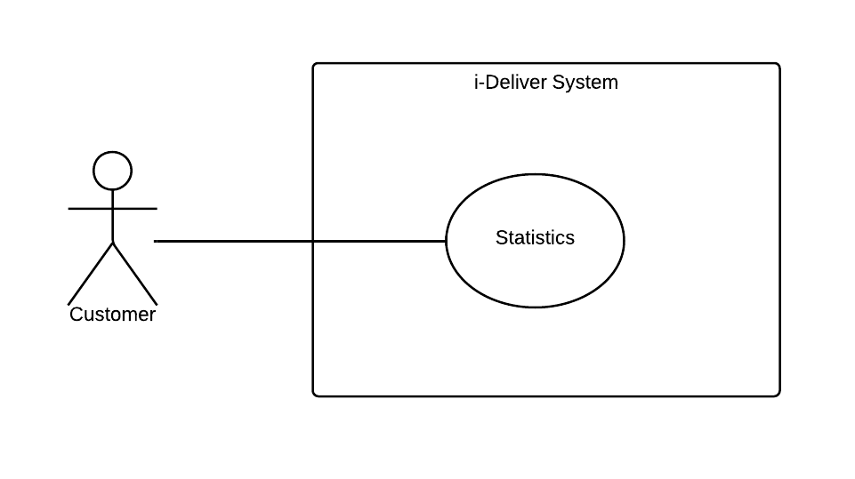

|  |  |  |  |  |
| --- | --- | --- | --- | --- |
| **– SPECIFICATION** | | | | |
| **Use-case No.** | UC0011 | **Use-case Version** | | 1.0 |
| **Use-case Name** | Statistics | | | |
| **Author** | DucNTSE60660 | | | |
| **Date** | 11/02/2014 | **Priority** | Normal | |
| **Actor:** Customer  **Summary:**  **Goal:**  .  **Triggers:**  .  **Preconditions:**  .  **Post Conditions:**  *On success:*  *On failure:*  **Main Success Scenario:**   |  |  |  | | --- | --- | --- | | **Step** | **User Action** | **System Response** | | 1. |  |  | | 2. |  |  | | 3. |  |  | | 4. |  |  | | 5. |  |  | | 6. |  |  |   **Alternative Scenario:**   |  |  |  |  | | --- | --- | --- | --- | | **No** | **Step** | **User Action** | **System Response** | | 1. | 1. |  |  | | 2. |  |  | | 2. | 1. |  |  | | 2. |  |  | | 3. | 1. |  |  | | 2. |  |  | | 3. | 1. |  |  | | 2. |  |  | | 4. | 1. |  |  | | 2. |  |  |   **Exceptions:**   |  |  |  | | --- | --- | --- | | **No** | **User Action** | **System Response** | | 1. |  |  | | 2. |  |  | | 3. |  |  | | 4. |  |  | | 5. |  |  | | 6. |  |  | | 7. |  |  | | 8. |  |  |   **Relationships:**  “Check room prices and availability” use case  **Business Rules:**   |  |  | | --- | --- | | **No** | **Business Rule Description** | | 1. |  | | 2. |  | | 3. |  | | | | | |

#### « Customer » Rating

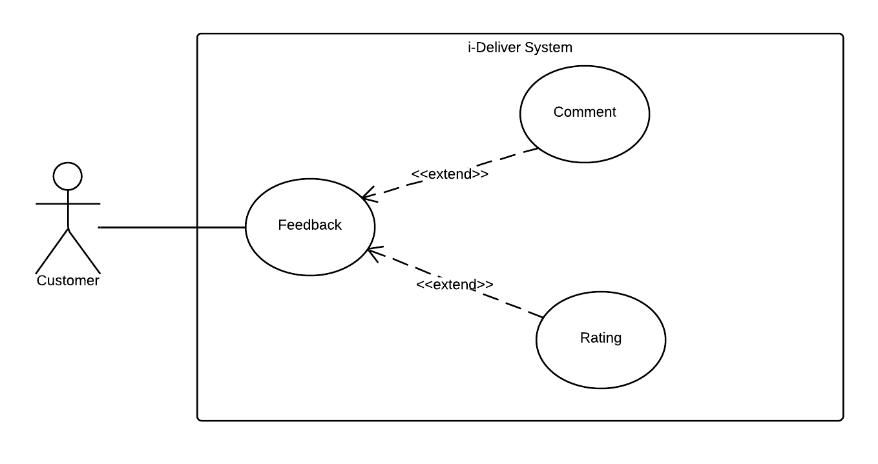

|  |  |  |  |  |
| --- | --- | --- | --- | --- |
| **RATING – SPECIFICATION** | | | | |
| **Use-case No.** | UC012 | **Use-case Version** | | 1.0 |
| **Use-case Name** | Rating | | | |
| **Author** | Lê Phúc Lữ | | | |
| **Date** | 09/02/2014 | **Priority** | Normal | |
| **Actor:** Customer.  **Summary:**  This use case allows customer can make a small feedback to center by rating the service of a specific route. When rating, he/she clicks to the star and the number of marked stars is the level of rating for this route.  **Goal:**  To rate the quality of the service of route of the center.  **Triggers:**  Customer clicks to the stars to rate after he/she used the service of this route.  **Preconditions:**  The customer enters to the page contains the list of route and for each route; there is a rating level corresponding.  **Post Conditions:**  *On success:* The star from the leftmost to the star that user clicked to are all marked. Then, there is a sentence notices the level of customer rated lies beside the list of stars, i.e., “Bạn đã đánh giá 4/5 điểm cho dịch vụ này”.  *On failure:* There is nothing changed and the star is not marked.  **Main Success Scenario:**   |  |  |  | | --- | --- | --- | | **Step** | **User Action** | **System Response** | | 1. | User click to one of five stars corresponding route to select the value that they think it should be. |  | | 2. |  | Display the information that user rated for the route: “Bạn đã đánh giá x/5 điểm cho tuyến đường này” with x is the rating level.  Saves the rating point for the route and updates the overall rating average point and rating average point for the currently rated route. |   **Alternative Scenario:**  N/A.  **Exceptions:**   |  |  |  | | --- | --- | --- | | **No** | **User Action** | **System Response** | | 1. | Customer clicks on the star but system encounters an exception when saving the rating point for the route. | Shows the popup to notice about the error “Không thể lưu đánh giá này do hệ thống có vấn đề”. |   **Relationships:**  “Clear rating” use case.  **Business Rules:**   |  |  | | --- | --- | | **No** | **Business Rule Description** | | 1. | This use case only for customer that logged in to the system so when guest rating, the i-Deliver check authentication and don’t perform the rating level. | | 2. | When user re-rates for the route, the old rate level will be updated by new rating. | | 3 | The rating level is the integer in interval [0; 5] inclusively but the average point maybe is a floating point number. | | | | | |

#### « Customer » Comment



|  |  |  |  |  |
| --- | --- | --- | --- | --- |
| **COMMENT – SPECIFICATION** | | | | |
| **Use-case No.** | UC013 | **Use-case Version** | | 1.0 |
| **Use-case Name** | Comment | | | |
| **Author** | Lê Phúc Lữ | | | |
| **Date** | 09/02/2014 | **Priority** | Normal | |
| **Actor:** Customer.  **Summary:**  This use case allows customer can make a small feedback to center by comment to the service of a specific route. When comment, he/she type the content of comment to the text box in the comment section of each route. After that, he/she click button “Gửi” or click “Enter” to submit the comment to system and this content will be display on the page of route. As long as submit the comment, he/she can edit or delete their own comment when they want.  **Goal:**  Comment the quality of the service of route of the center.  **Triggers:**  Customer can comment to route after he/she used the service of this route.  **Preconditions:**  The customer enter to the page contains the list of route and for each route, there is text box to input the content of comment corresponding.  **Post Conditions:**  *On success:* The content of comment display on the page of route that customer concerned.  *On failure:* User can input the comment to text box but cannot submit this content to system  **Main Success Scenario:**   |  |  |  | | --- | --- | --- | | **Step** | **User Action** | **System Response** | | 1. | Customer inputs the content of comment to the text box then clicks to button “Gửi”. |  | | 2. |  | Displays the content of comment that user input. Name of button “Gửi” will be changed to “Chỉnh sửa” so when user want to modify their comment, he/she can click to this button, modify and resubmit. |   **Alternative Scenario:**   |  |  |  |  | | --- | --- | --- | --- | | **No** | **Step** | **User Action** | **System Response** | | 1. | 1. | Customer doesn’t input anything to the text box and clicks to button “Gửi” |  | | 2. |  | Displays the popup notice that they want to input the text at least 3 characters, i.e., “Nhận xét của bạn phải có ít nhất 3 kí tự, mời bạn nhập lại”. | | 2. | 1. | Customer inputs the content of comment to the text box and he/she doesn’t click to button “Gửi”, then they click to Back on browse or close the window. |  | | 2. |  | Display the popup notice that they still not submit the comment to system and can be lost it by exit the window. |   **Exceptions:**   |  |  |  | | --- | --- | --- | | **No** | **User Action** | **System Response** | | 1. | Customer inputs the content of comment to the text box then clicks to button “Gửi”. | Shows the popup to notice about the error “Không thể hiện nhận xét này do hệ thống có vấn đề”. | | 2. | After customer submits the comment, he/she want to modify the content, they clicks to button “Chỉnh sửa”. | Shows the popup to notice about the error “Không thể chỉnh sửa nhận xét này do hệ thống có vấn đề”. |   **Relationships:**  “Delete comment” use case.  **Business Rules:**   |  |  | | --- | --- | | **No** | **Business Rule Description** | | 1. | When customer comments to the route, they can modify the content but cannot delete it. The comment is point to quality of the service, not for reply the other comment so can be delete if illegal. | | 2. | The content of comment is at least 3 characters differ to “space” character. | | | | | |

#### « System administrator » Define delivery fee value/calculating formula

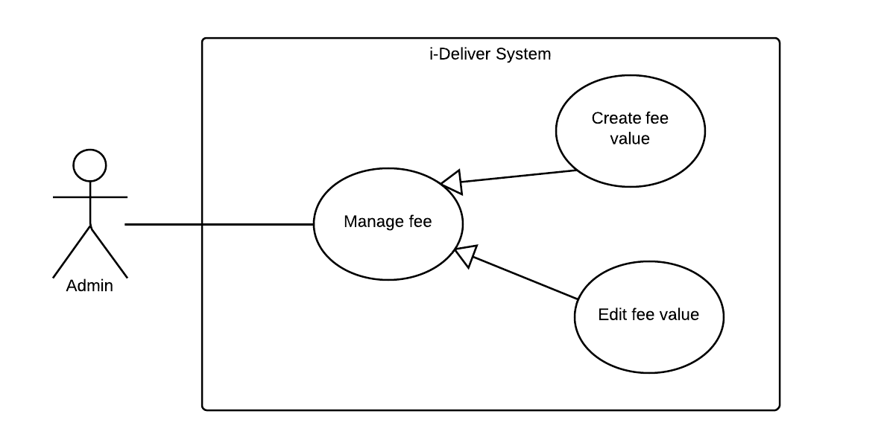

|  |  |  |  |  |
| --- | --- | --- | --- | --- |
| **DEFINE DELIVERY FEE VALUE – SPECIFICATION** | | | | |
| **Use-case No.** | UC014 | **Use-case Version** | | 1.0 |
| **Use-case Name** | Define delivery fee value/calculating formula | | | |
| **Author** | Lê Phúc Lữ | | | |
| **Date** | 10/02/2014 | **Priority** | Normal | |
| **Actor:** System administrator (admin).  **Summary:**  This use case allows admin can create the fee of delivery service base on the weight and volume of package. In detail, he/she can define the range of weight including max and min value of package’s weight; then, for each range, define the range of volume that also including max and min value of package’s volume. For a specific range, create the fee for deliver this corresponding package.  **Goal:**  To create the fee for deliver package base on its weight and volume.  **Triggers:**  N/A.  **Preconditions:**  Admin logged in to the system and enter to the fee setting page and he/she doesn’t setting anything about the fee before.  **Post Conditions:**  *On success:* The information of fee value will be inserted successfully.  *On failure:* The information of fee value not inserted or insert incorrectly.  **Main Success Scenario:**   |  |  |  | | --- | --- | --- | | **Step** | **User Action** | **System Response** | | 1. |  |  | | 2. |  |  |   **Alternative Scenario:**  N/A.  **Exceptions:**   |  |  |  | | --- | --- | --- | | **No** | **User Action** | **System Response** | | 1. |  |  |   **Relationships:**  “Edit fee value” use case.  **Business Rules:**   |  |  | | --- | --- | | **No** | **Business Rule Description** | | 1. |  | | 2. |  | | 3 |  | | | | | |

#### « System administrator » Edit delivery fee value/ calculating formula



|  |  |  |  |  |
| --- | --- | --- | --- | --- |
| **EDIT DELIVERY FEE VALUE – SPECIFICATION** | | | | |
| **Use-case No.** | UC016 | **Use-case Version** | | 1.0 |
| **Use-case Name** | Edit delivery fee value / calculating formula | | | |
| **Author** | Lê Phúc Lữ | | | |
| **Date** | 10/02/2014 | **Priority** | Normal | |
| **Actor:** System administrator (admin).  **Summary:**  This use case allows admin can modify the fee of delivery service base on the weight and volume of package. After he/she define information before, he/she can update the range of weight including max and min value of package’s weight; the range of volume that also including max and min value of package’s volume and also the fee for each range of weight and volume.  **Goal:**  To edit the fee for deliver package base on its weight and volume.  **Triggers:**  Admin define the fee value before.  **Preconditions:**  Admin logged in to the system and enter to the fee setting page.  **Post Conditions:**  *On success:* The information of fee value updated successfully.  *On failure:* The information of fee value not updated or updated incorrectly.  **Main Success Scenario:**   |  |  |  | | --- | --- | --- | | **Step** | **User Action** | **System Response** | | 1. |  |  | | 2. |  |  |   **Alternative Scenario:**  N/A.  **Exceptions:**   |  |  |  | | --- | --- | --- | | **No** | **User Action** | **System Response** | | 1. |  |  |   **Relationships:**  “Add fee value” use case.  **Business Rules:**   |  |  | | --- | --- | | **No** | **Business Rule Description** | | 1. |  | | 2. |  | | 3 |  | | | | | |

#### « System administrator » Create new staff account

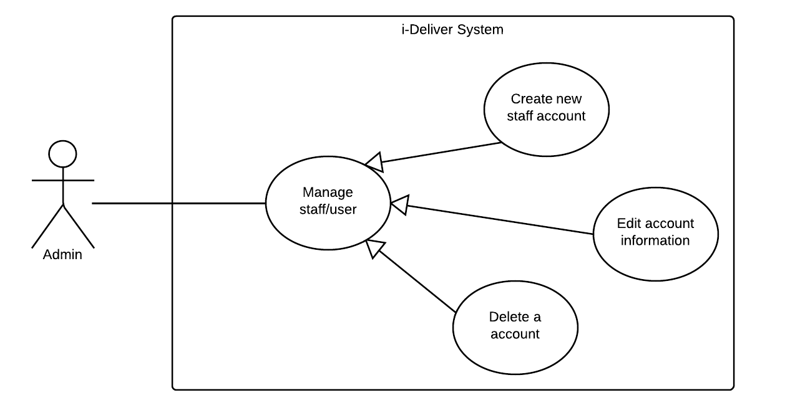

|  |  |  |  |  |
| --- | --- | --- | --- | --- |
| **CREATE NEW STAFF ACCOUNT – SPECIFICATION** | | | | |
| **Use-case No.** | UC016 | **Use-case Version** | | 1.0 |
| **Use-case Name** | Create new staff account | | | |
| **Author** | Lê Phúc Lữ | | | |
| **Date** | 10/02/2014 | **Priority** | Normal | |
| **Actor:** System administrator (admin).  **Summary:**  The staffs have an important role in the system when they manage almost the action of system. Admin can create new staff account with username and password but without the basic information as the customer (it is no need on the system). The staff role is authorized to access some specific pages to manage.  **Goal:**  Create new staff account.  **Triggers:**  N/A.  **Preconditions:**  Admin logged in to the system and enter to the manage account page.  **Post Conditions:**  *On success:* New account with correct account and password insert successfully.  *On failure:* No new account added or wrong information added.  **Main Success Scenario:**   |  |  |  | | --- | --- | --- | | **Step** | **User Action** | **System Response** | | 1. |  |  | | 2. |  |  |   **Alternative Scenario:**  N/A.  **Exceptions:**   |  |  |  | | --- | --- | --- | | **No** | **User Action** | **System Response** | | 1. |  |  |   **Relationships:**  “Add fee value” use case.  **Business Rules:**   |  |  | | --- | --- | | **No** | **Business Rule Description** | | 1. |  | | 2. |  | | 3 |  | | | | | |

#### « System administrator» Edit account information



|  |  |  |  |  |
| --- | --- | --- | --- | --- |
| **EDIT ACCOUNT INFORMATION – SPECIFICATION** | | | | |
| **Use-case No.** | UC017 | **Use-case Version** | | 1.0 |
| **Use-case Name** | Edit account information | | | |
| **Author** | Lê Phúc Lữ | | | |
| **Date** | 10/02/2014 | **Priority** | Normal | |
| **Actor:** System administrator (admin).  **Summary:**  This use case allows admin can update the information of staff or user account due to some special reason.  **Goal:**  Edit the account (including staff and customer) information.  **Triggers:**  N/A.  **Preconditions:**  Admin logged in to the system and enter to the manage account page.  **Post Conditions:**  *On success:* The updated information is saved successfully.  *On failure:* No new update information are saved or information incorrect.  **Main Success Scenario:**   |  |  |  | | --- | --- | --- | | **Step** | **User Action** | **System Response** | | 1. |  |  | | 2. |  |  |   **Alternative Scenario:**  N/A.  **Exceptions:**   |  |  |  | | --- | --- | --- | | **No** | **User Action** | **System Response** | | 1. |  |  |   **Relationships:**  “Add fee value” use case.  **Business Rules:**   |  |  | | --- | --- | | **No** | **Business Rule Description** | | 1. |  | | 2. |  | | 3 |  | | | | | |

#### « System administrator » Delete account



|  |  |  |  |  |
| --- | --- | --- | --- | --- |
| **DELETE ACCOUNT – SPECIFICATION** | | | | |
| **Use-case No.** | UC018 | **Use-case Version** | | 1.0 |
| **Use-case Name** | Delete account | | | |
| **Author** | Lê Phúc Lữ | | | |
| **Date** | 10/02/2014 | **Priority** | Normal | |
| **Actor:** System administrator (admin).  **Summary:**  This use case allows admin can delete account of staff or customer. When some staff don’t work for the center anymore so he/she cannot access to the manage page of system. And in the other, if some customer has registered an account at the page for the bad objective, then admin can delete their account.  **Goal:**  Delete the account of staff or customer.  **Triggers:**  N/A.  **Preconditions:**  Admin logged in to the system and enter to the manage account page.  **Post Conditions:**  *On success:* The account delete successfully.  *On failure:* The account still not is deleted.  **Main Success Scenario:**   |  |  |  | | --- | --- | --- | | **Step** | **User Action** | **System Response** | | 1. |  |  | | 2. |  |  |   **Alternative Scenario:**  N/A.  **Exceptions:**   |  |  |  | | --- | --- | --- | | **No** | **User Action** | **System Response** | | 1. |  |  |   **Relationships:**  N/A.  **Business Rules:**   |  |  | | --- | --- | | **No** | **Business Rule Description** | | 1. |  | | 2. |  | | 3 |  | | | | | |

#### « System administrator » Search information

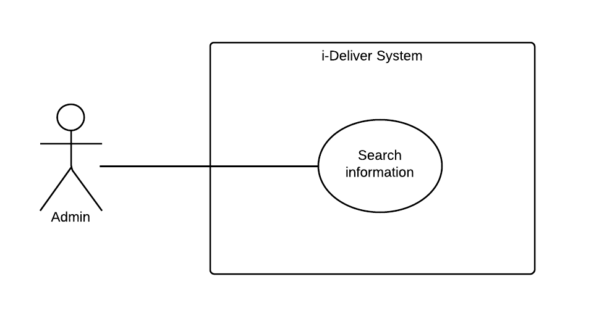

|  |  |  |  |  |
| --- | --- | --- | --- | --- |
| **SEARCH INFORMATION – SPECIFICATION** | | | | |
| **Use-case No.** | UC019 | **Use-case Version** | | 1.0 |
| **Use-case Name** | Search information | | | |
| **Author** | Lê Phúc Lữ | | | |
| **Date** | 10/02/2014 | **Priority** | Normal | |
| **Actor:** System administrator (admin).  **Summary:**  This use case allows admin search some specific information for management, especially search account.  **Goal:**  Search information of account with the key word.  **Triggers:**  N/A.  **Preconditions:**  Admin logged in to the system and enter to the manage account page.  **Post Conditions:**  *On success:* The account match with the searching criteria will be found and display on the page result of search process.  *On failure:* Wrong account display on the page result.  **Main Success Scenario:**   |  |  |  | | --- | --- | --- | | **Step** | **User Action** | **System Response** | | 1. |  |  | | 2. |  |  |   **Alternative Scenario:**  N/A.  **Exceptions:**   |  |  |  | | --- | --- | --- | | **No** | **User Action** | **System Response** | | 1. |  |  |   **Relationships:**  N/A.  **Business Rules:**   |  |  | | --- | --- | | **No** | **Business Rule Description** | | 1. |  | | 2. |  | | 3 |  | | | | | |

#### « System administrator» Statistic

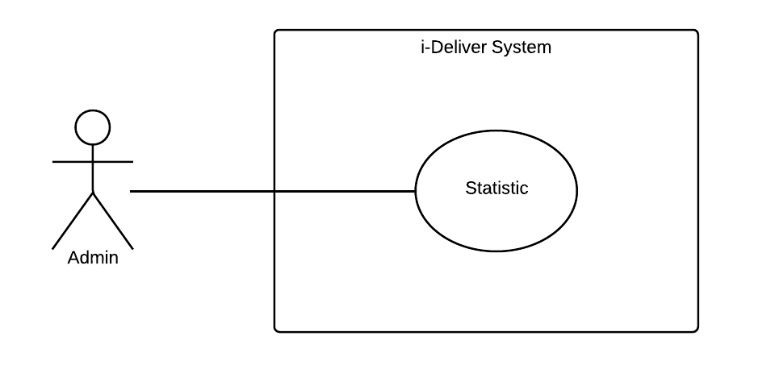

|  |  |  |  |  |
| --- | --- | --- | --- | --- |
| **STATISTIC – SPECIFICATION** | | | | |
| **Use-case No.** | UC020 | **Use-case Version** | | 1.0 |
| **Use-case Name** | Statistic | | | |
| **Author** | Lê Phúc Lữ | | | |
| **Date** | 10/02/2014 | **Priority** | Normal | |
| **Actor:** System administrator (admin).  **Summary:**  This use case allows admin statistic information of system, especially statistic on customer account.  **Goal:**  Statistic the information of account.  **Triggers:**  N/A.  **Preconditions:**  Admin logged in to the system and enter to the statistic page.  **Post Conditions:**  *On success:* The result of statistic information will be displayed.  *On failure:* The statistic information is not displayed.  **Main Success Scenario:**   |  |  |  | | --- | --- | --- | | **Step** | **User Action** | **System Response** | | 1. |  |  | | 2. |  |  |   **Alternative Scenario:**  N/A.  **Exceptions:**   |  |  |  | | --- | --- | --- | | **No** | **User Action** | **System Response** | | 1. |  |  |   **Relationships:**  N/A.  **Business Rules:**   |  |  | | --- | --- | | **No** | **Business Rule Description** | | 1. |  | | 2. |  | | 3 |  | | | | | |

#### « Staff » Approve request

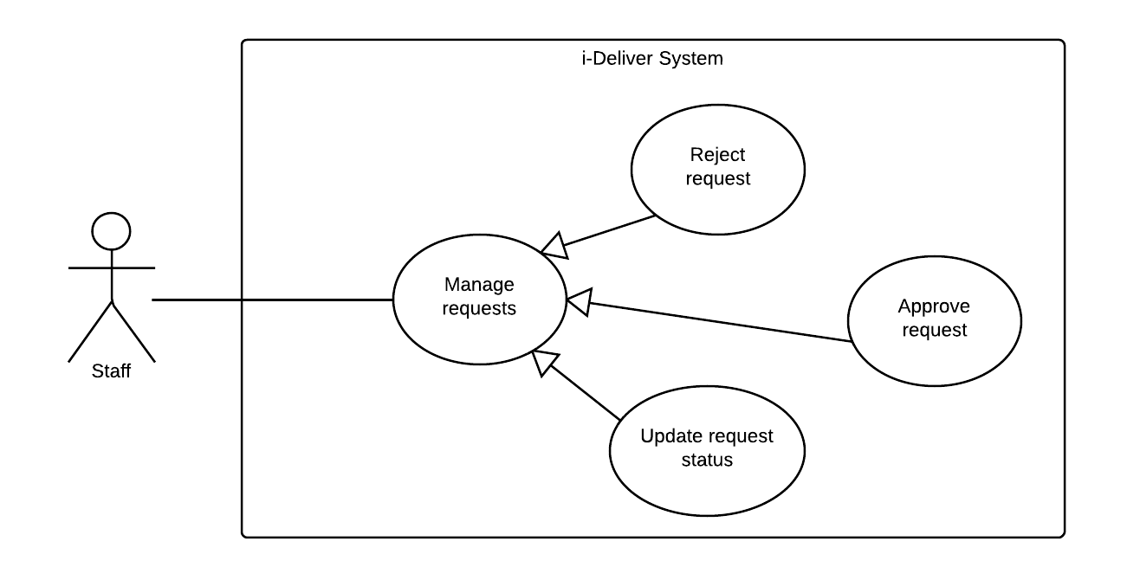

|  |  |  |  |  |
| --- | --- | --- | --- | --- |
| **– SPECIFICATION** | | | | |
| **Use-case No.** | UC001 | **Use-case Version** | | 1.0 |
| **Use-case Name** | Approve request | | | |
| **Author** | Nguyễn Thanh Tùng | | | |
| **Date** | 10/2/2014 | **Priority** | High | |
| **Actor:**  *Staffs*  **Summary:**  This use case allows staffs to approve a request from customers or in other words the staffs will change the status of request.  **Goal:**  To confirm a request is valid and that request will be processed.  **Triggers:**  .The staffs click on button “Chấp thuận” on the staff page.  **Preconditions:**  .The staff page is being displayed.  **Post Conditions:**  *On success:* The request’s status will be changed  *On failure:* An error message is displayed. The content of the error message will be based on the type of failure.  **Main Success Scenario:**   |  |  |  | | --- | --- | --- | | **Step** | **User Action** | **System Response** | | 1. |  |  | | 2. |  |  | | 3. |  |  | | 4. |  |  | | 5. |  |  | | 6. |  |  |   **Alternative Scenario:**   |  |  |  |  | | --- | --- | --- | --- | | **No** | **Step** | **User Action** | **System Response** | | 1. | 1. |  |  | | 2. |  |  | | 2. | 1. |  |  | | 2. |  |  | | 3. | 1. |  |  | | 2. |  |  | | 3. | 1. |  |  | | 2. |  |  | | 4. | 1. |  |  | | 2. |  |  |   **Exceptions:**   |  |  |  | | --- | --- | --- | | **No** | **User Action** | **System Response** | | 1. |  |  | | 2. |  |  | | 3. |  |  | | 4. |  |  | | 5. |  |  | | 6. |  |  | | 7. |  |  | | 8. |  |  |   **Relationships:**  **Business Rules:**   |  |  | | --- | --- | | **No** | **Business Rule Description** | | 1. |  | | 2. |  | | 3. |  | | | | | |

#### « Staff » Reject request



|  |  |  |  |  |
| --- | --- | --- | --- | --- |
| **– SPECIFICATION** | | | | |
| **Use-case No.** | UC001 | **Use-case Version** | | 1.0 |
| **Use-case Name** | Reject request | | | |
| **Author** | Nguyễn Thanh Tùng | | | |
| **Date** | 10/2/2014 | **Priority** | High | |
| **Actor:**  Staffs  **Summary:**  This use case allows staffs to delete a request from manager page.  **Goal:**  .To reject a request because it’s may be not valid or in a period time, don’t have any response from customers.  **Triggers:**  .The staffs click on button “Xóa” on the staff pages.  **Preconditions:**  . The staff page is being displayed.  **Post Conditions:**  *On success:* The request will be removed.  *On failure:* An error message is displayed. The content of the error message will be based on the type of failure.  **Main Success Scenario:**   |  |  |  | | --- | --- | --- | | **Step** | **User Action** | **System Response** | | 1. |  |  | | 2. |  |  | | 3. |  |  | | 4. |  |  | | 5. |  |  | | 6. |  |  |   **Alternative Scenario:**   |  |  |  |  | | --- | --- | --- | --- | | **No** | **Step** | **User Action** | **System Response** | | 1. | 1. |  |  | | 2. |  |  | | 2. | 1. |  |  | | 2. |  |  | | 3. | 1. |  |  | | 2. |  |  | | 3. | 1. |  |  | | 2. |  |  | | 4. | 1. |  |  | | 2. |  |  |   **Exceptions:**   |  |  |  | | --- | --- | --- | | **No** | **User Action** | **System Response** | | 1. |  |  | | 2. |  |  | | 3. |  |  | | 4. |  |  | | 5. |  |  | | 6. |  |  | | 7. |  |  | | 8. |  |  |   **Relationships:**  “Check room prices and availability” use case  **Business Rules:**   |  |  | | --- | --- | | **No** | **Business Rule Description** | | 1. |  | | 2. |  | | 3. |  | | | | | |

#### « Staff » Assign package

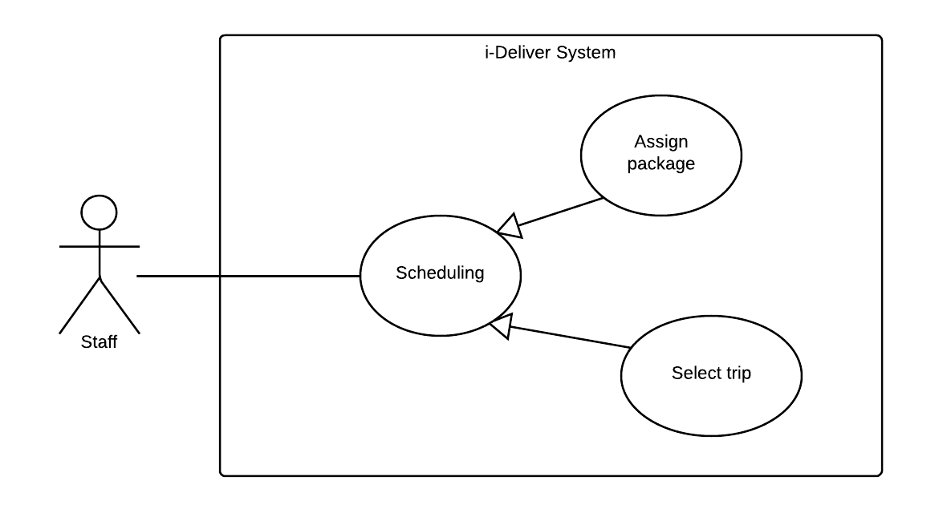

|  |  |  |  |  |
| --- | --- | --- | --- | --- |
| **– SPECIFICATION** | | | | |
| **Use-case No.** | UC001 | **Use-case Version** | | 1.0 |
| **Use-case Name** | Assign package | | | |
| **Author** | Nguyễn Thanh Tùng | | | |
| **Date** | 10/02/2014 | **Priority** | High | |
| **Actor:**  *Staffs*  **Summary:**  This use case allows staffs assign a request to which car, route…follow the content of request, and request will be become a package.  **Goal:**  .To transport package according to customer requirements  **Triggers:**  .  **Preconditions:**  .The request must be approved.  **Post Conditions:**  *On success:* Package will be assigned.  *On failure:* An error message is displayed. The content of the error message will be based on the type of failure.  **Main Success Scenario:**   |  |  |  | | --- | --- | --- | | **Step** | **User Action** | **System Response** | | 1. |  |  | | 2. |  |  | | 3. |  |  | | 4. |  |  | | 5. |  |  | | 6. |  |  |   **Alternative Scenario:**   |  |  |  |  | | --- | --- | --- | --- | | **No** | **Step** | **User Action** | **System Response** | | 1. | 1. |  |  | | 2. |  |  | | 2. | 1. |  |  | | 2. |  |  | | 3. | 1. |  |  | | 2. |  |  | | 3. | 1. |  |  | | 2. |  |  | | 4. | 1. |  |  | | 2. |  |  |   **Exceptions:**   |  |  |  | | --- | --- | --- | | **No** | **User Action** | **System Response** | | 1. |  |  | | 2. |  |  | | 3. |  |  | | 4. |  |  | | 5. |  |  | | 6. |  |  | | 7. |  |  | | 8. |  |  |   **Relationships:**  **Business Rules:**   |  |  | | --- | --- | | **No** | **Business Rule Description** | | 1. |  | | 2. |  | | 3. |  | | | | | |

#### « Staff » Update request status



|  |  |  |  |  |
| --- | --- | --- | --- | --- |
| **– SPECIFICATION** | | | | |
| **Use-case No.** | UC001 | **Use-case Version** | | 1.0 |
| **Use-case Name** | Update request status | | | |
| **Author** | Nguyễn Thanh Tùng | | | |
| **Date** | 10/02/2014 | **Priority** | High | |
| **Actor:**  *Staffs*  **Summary:**  The use case allows staffs update status of a package when it’s assigned.  **Goal:**  .To notifies to customers about their package through the status of package: on way or waiting.., help their tracking package.  **Triggers:**  .Staffs click on button”Thay đổi trạng thái” on staff’s page.  **Preconditions:**  .Package must be assigned.  **Post Conditions:**  *On success:* Status of package will be changed.  *On failure:* An error message is displayed. The content of the error message will be based on the type of failure.  **Main Success Scenario:**   |  |  |  | | --- | --- | --- | | **Step** | **User Action** | **System Response** | | 1. |  |  | | 2. |  |  | | 3. |  |  | | 4. |  |  | | 5. |  |  | | 6. |  |  |   **Alternative Scenario:**   |  |  |  |  | | --- | --- | --- | --- | | **No** | **Step** | **User Action** | **System Response** | | 1. | 1. |  |  | | 2. |  |  | | 2. | 1. |  |  | | 2. |  |  | | 3. | 1. |  |  | | 2. |  |  | | 3. | 1. |  |  | | 2. |  |  | | 4. | 1. |  |  | | 2. |  |  |   **Exceptions:**   |  |  |  | | --- | --- | --- | | **No** | **User Action** | **System Response** | | 1. |  |  | | 2. |  |  | | 3. |  |  | | 4. |  |  | | 5. |  |  | | 6. |  |  | | 7. |  |  | | 8. |  |  |   **Relationships:**  **Business Rules:**   |  |  | | --- | --- | | **No** | **Business Rule Description** | | 1. |  | | 2. |  | | 3. |  | | | | | |

#### « Staff » Select trip



|  |  |  |  |  |
| --- | --- | --- | --- | --- |
| **– SPECIFICATION** | | | | |
| **Use-case No.** | UC001 | **Use-case Version** | | 1.0 |
| **Use-case Name** | Select trip | | | |
| **Author** | Nguyễn Thanh Tùng | | | |
| **Date** | 10/02/2014 | **Priority** | High | |
| **Actor:**  *Staffs*  **Summary:**  …  **Goal:**  .  **Triggers:**  .  **Preconditions:**  .  **Post Conditions:**  *On success:*  *On failure:* An error message is displayed. The content of the error message will be based on the type of failure.  **Main Success Scenario:**   |  |  |  | | --- | --- | --- | | **Step** | **User Action** | **System Response** | | 1. |  |  | | 2. |  |  | | 3. |  |  | | 4. |  |  | | 5. |  |  | | 6. |  |  |   **Alternative Scenario:**   |  |  |  |  | | --- | --- | --- | --- | | **No** | **Step** | **User Action** | **System Response** | | 1. | 1. |  |  | | 2. |  |  | | 2. | 1. |  |  | | 2. |  |  | | 3. | 1. |  |  | | 2. |  |  | | 3. | 1. |  |  | | 2. |  |  | | 4. | 1. |  |  | | 2. |  |  |   **Exceptions:**   |  |  |  | | --- | --- | --- | | **No** | **User Action** | **System Response** | | 1. |  |  | | 2. |  |  | | 3. |  |  | | 4. |  |  | | 5. |  |  | | 6. |  |  | | 7. |  |  | | 8. |  |  |   **Relationships:**  “Check room prices and availability” use case  **Business Rules:**   |  |  | | --- | --- | | **No** | **Business Rule Description** | | 1. |  | | 2. |  | | 3. |  | | | | | |

#### « Staff » Search package

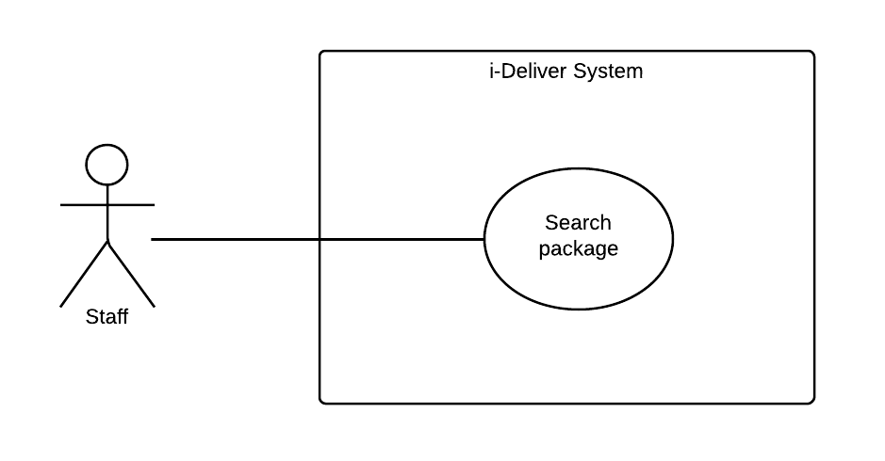

|  |  |  |  |  |
| --- | --- | --- | --- | --- |
| **– SPECIFICATION** | | | | |
| **Use-case No.** | UC001 | **Use-case Version** | | 1.0 |
| **Use-case Name** | Search Package | | | |
| **Author** | Nguyễn Thanh Tùng | | | |
| **Date** | 10/02/2014 | **Priority** | High | |
| **Actor:**  *Staffs*  **Summary:**  This use case allows staffs search information of package such as package name, assign to which car…  **Goal:**  .To search package for tracking and checking information.  **Triggers:**  .Staffs click on button “Tìm kiếm”  **Preconditions:**  .Staffs page being displayed.  **Post Conditions:**  *On success:* A list of packages is displayed.  *On failure:* An error message is displayed. The content of the error message will be based on the type of failure.  **Main Success Scenario:**   |  |  |  | | --- | --- | --- | | **Step** | **User Action** | **System Response** | | 1. |  |  | | 2. |  |  | | 3. |  |  | | 4. |  |  | | 5. |  |  | | 6. |  |  |   **Alternative Scenario:**   |  |  |  |  | | --- | --- | --- | --- | | **No** | **Step** | **User Action** | **System Response** | | 1. | 1. |  |  | | 2. |  |  | | 2. | 1. |  |  | | 2. |  |  | | 3. | 1. |  |  | | 2. |  |  | | 3. | 1. |  |  | | 2. |  |  | | 4. | 1. |  |  | | 2. |  |  |   **Exceptions:**   |  |  |  | | --- | --- | --- | | **No** | **User Action** | **System Response** | | 1. |  |  | | 2. |  |  | | 3. |  |  | | 4. |  |  | | 5. |  |  | | 6. |  |  | | 7. |  |  | | 8. |  |  |   **Relationships:**  “Check room prices and availability” use case  **Business Rules:**   |  |  | | --- | --- | | **No** | **Business Rule Description** | | 1. |  | | 2. |  | | 3. |  | | | | | |

#### « Staff » Statistics

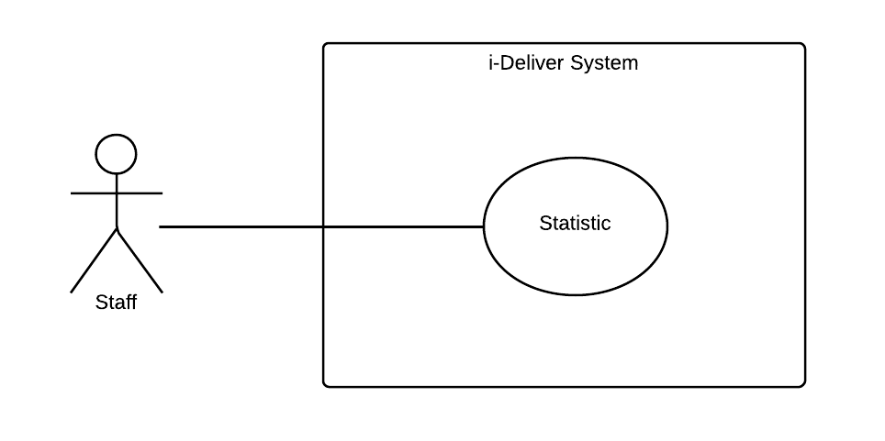

|  |  |  |  |  |
| --- | --- | --- | --- | --- |
| **– SPECIFICATION** | | | | |
| **Use-case No.** | UC001 | **Use-case Version** | |  |
| **Use-case Name** |  | | | |
| **Author** |  | | | |
| **Date** |  | **Priority** |  | |
| **Actor:**  **Summary:**  …  **Goal:**  .  **Triggers:**  .  **Preconditions:**  .  **Post Conditions:**  *On success:*  *On failure:*  **Main Success Scenario:**   |  |  |  | | --- | --- | --- | | **Step** | **User Action** | **System Response** | | 1. |  |  | | 2. |  |  | | 3. |  |  | | 4. |  |  | | 5. |  |  | | 6. |  |  |   **Alternative Scenario:**   |  |  |  |  | | --- | --- | --- | --- | | **No** | **Step** | **User Action** | **System Response** | | 1. | 1. |  |  | | 2. |  |  | | 2. | 1. |  |  | | 2. |  |  | | 3. | 1. |  |  | | 2. |  |  | | 3. | 1. |  |  | | 2. |  |  | | 4. | 1. |  |  | | 2. |  |  |   **Exceptions:**   |  |  |  | | --- | --- | --- | | **No** | **User Action** | **System Response** | | 1. |  |  | | 2. |  |  | | 3. |  |  | | 4. |  |  | | 5. |  |  | | 6. |  |  | | 7. |  |  | | 8. |  |  |   **Relationships:**  **Business Rules:**   |  |  | | --- | --- | | **No** | **Business Rule Description** | | 1. |  | | 2. |  | | 3. |  | | | | | |

#### « Staff » Create a trip

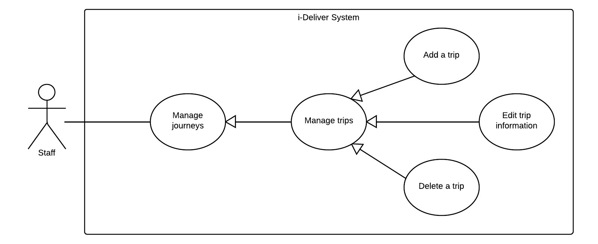

|  |  |  |  |  |
| --- | --- | --- | --- | --- |
| **ADD A TRIP – SPECIFICATION** | | | | |
| **Use-case No.** | UC029 | **Use-case Version** | | 1.0 |
| **Use-case Name** | Create new trip | | | |
| **Author** | LongDB | | | |
| **Date** | 10/02/2014 | **Priority** | Normal | |
| **Actor:**  *Staff*  **Summary:**  …  **Goal:**  To manually open a new trip in the i-Deliver system  **Triggers:**  The user clicks on the button “Tạo một chuyến mới” on the trip management page.  **Preconditions:**  The user is already logged in with an account of Staff role.  **Post Conditions:**  *On success:* A new trip was added to system’s database. The user is redirected to trip list page which is now has a section that describes the currently added trip.  *On failure:* An error message is displayed. Please refer to the Exception Scenario section the see what the content of the error message is.  **Main Success Scenario:**   |  |  |  | | --- | --- | --- | | **Step** | **User Action** | **System Response** | | 1. | Clicks on the button “Tạo một chuyến mới”. |  | | 2. | Fills out the form with relevant values.  [See Exception No. 1, 2, 3, 4, 5, 6, 7, 8, 9, 10, 11, 12, 13] |  | | 3. | Clicks the button “Tạo mới”  [See Alternative No. 1, 2] |  | | 4. |  | Saves the trip to the database and redirects the user to the trip list page which now has a new section that describes the newly added trip.  [See Exception No. 14] |   **Alternative Scenario:**   |  |  |  |  | | --- | --- | --- | --- | | **No** | **Step** | **User Action** | **System Response** | | 1. | 1. | Clicks on the button “Hủy”. |  | | 2. |  | Shows a popup to ask the user to confirm the action. | | 2. | 1. | The user chooses “OK”. |  | | 2. |  | If the user confirms to go back, redirects the user to the list page, otherwise, just hide the popup. | | 3. | 1. | Clicks on the button “Tạo mới”. |  | | 2. |  | Saves the trip to the database and redirects the user to the trip list page. |   **Exceptions:**   |  |  |  | | --- | --- | --- | | **No** | **User Action** | **System Response** | | 1. |  |  | | 2. |  |  | | 3. |  |  | | 4. |  |  | | 5. |  |  | | 6. |  |  | | 7. |  |  | | 8. |  |  |   **Relationships:**  N/A  **Business Rules:**   |  |  | | --- | --- | | **No** | **Business Rule Description** | | 1. | A new trip can be created for a route if only that route had defined schedule. | | 2. | Before create a new trip, user must select a date to review all trip created in that day in order to avoid duplicate. | | 3. | Once time user pick a date to create new trip, the i-Deliver system will create trip for 7 days continuous automatically | | | | | |

#### « Staff » Edit trip information



|  |  |  |  |  |
| --- | --- | --- | --- | --- |
| **EDIT TRIP INFORMATION – SPECIFICATION** | | | | |
| **Use-case No.** | UC030 | **Use-case Version** | | 1.0 |
| **Use-case Name** | Edit trip’s information | | | |
| **Author** | LongDB | | | |
| **Date** | 10/02/2014 | **Priority** | Normal | |
| **Actor:**  *Staff*  **Summary:**  This use case allows a staff to view and manually change information about an existing trip in the database.  **Goal:**  To manually edit information of an existing trip in the system.  **Triggers:**  The user clicks on the button “Thông tin chuyến” on trip management page.  **Preconditions:**  The user is already logged in with an account of Staff role.  The trip management page is being displayed.  **Post Conditions:**  *On success:* The information of selected trip is updated in the system. The user is redirect to the trip management page where information is currently updated.  *On failure:* An error message is displayed. The content of the error message will be specified in the Exception Scenario section based on the type of failure.  **Main Success Scenario:**   |  |  |  | | --- | --- | --- | | **Step** | **User Action** | **System Response** | | 1. | Clicks on trip user want to edit information |  | | 2. |  | Shows a popup with trip details and update buttons | | 3. | Clicks on the button “Chỉnh sửa thông tin” |  | | 4. |  | Redirect to trip information update page which now has a new section that describes the | | 5. | Fills out the form with relevant values. |  | | 3. | Clicks the button “Lưu thông tin”  [See Alternative No. 1, 2] |  | | 4. |  | Saves new trip information to the database and redirects the user to the trip list page |   **Alternative Scenario:**   |  |  |  |  | | --- | --- | --- | --- | | **No** | **Step** | **User Action** | **System Response** | | 1. | 1. | Clicks on the button “Hủy”. |  | | 2. |  | Shows a popup to ask the user to confirm the action. | | 2. | 1. | The user chooses “OK”. |  | | 2. |  | If the user confirms to go back, redirects the user to the list page, otherwise, just hide the popup. | | 3. | 1. | Clicks on the button “Lưu thông tin”. |  | | 2. |  | Saves the trip to the database and redirects the user to the trip list page. |   **Exceptions:**   |  |  |  | | --- | --- | --- | | **No** | **User Action** | **System Response** | | 1. |  |  | | 2. |  |  | | 3. |  |  | | 4. |  |  | | 5. |  |  | | 6. |  |  | | 7. |  |  | | 8. |  |  |   **Relationships:**  “Add a trip” use case  **Business Rules:**   |  |  | | --- | --- | | **No** | **Business Rule Description** | | 1. |  | | 2. |  | | 3. |  | | | | | |

#### « Staff » Delete a trip



|  |  |  |  |  |
| --- | --- | --- | --- | --- |
| **DELETE A TRIP – SPECIFICATION** | | | | |
| **Use-case No.** | UC031 | **Use-case Version** | | 1.0 |
| **Use-case Name** | Delete a trip | | | |
| **Author** | LongDB | | | |
| **Date** | 10/02/2014 | **Priority** | Normal | |
| **Actor:**  *Staff*  **Summary:**  This use case allows a staff to remove an existing trip from the system.  **Goal:**  To manually remove an existing trip from the system.  **Triggers:**  The staff clicks on the button “Xóa chuyến” on the section that contains the trip to be deleted in the trip management page.  **Preconditions:**  The user is already logged in with an account of Staff role.  The trip management page is being displayed.  The trip to be deleted is being selected.  **Post Conditions:**  *On success:* The selected trip is deleted from the system databse. The row that contains the selected trip is removed from the trip list page.  *On failure:* An error message is displayed. The content of the error message will be specified in the Exception Scenario section based on the type of failure.  **Main Success Scenario:**   |  |  |  | | --- | --- | --- | | **Step** | **User Action** | **System Response** | | 1. | Clicks on the button “Xóa” on the row that contains the trip to be deleted. |  | | 2. |  | [See Exception No. 1]  Shows a popup to ask the staff to confirm the action. | | 3. | Chooses “OK” to continue to delete the trip.  [See Alternative No. 1] | Marks the selected trip as deleted in the database.  Removes the row that contains the selected trip from the trip list page.  [See Exception No. 2, 3] |   **Alternative Scenario:**   |  |  |  |  | | --- | --- | --- | --- | | **No** | **Step** | **User Action** | **System Response** | | 1. | 1. | Clicks on the button “Hủy bỏ”. |  | | 2. |  | Hides the popup message box. |   **Exceptions:**   |  |  |  | | --- | --- | --- | | **No** | **User Action** | **System Response** | | 1. |  |  | | 2. |  |  | | 3. |  |  | | 4. |  |  | | 5. |  |  | | 6. |  |  | | 7. |  |  | | 8. |  |  |   **Relationships:**  “Add a trip” use case  **Business Rules:**   |  |  | | --- | --- | | **No** | **Business Rule Description** | | 1. |  | | 2. |  | | 3. |  | | | | | |

#### « Staff » Add a station

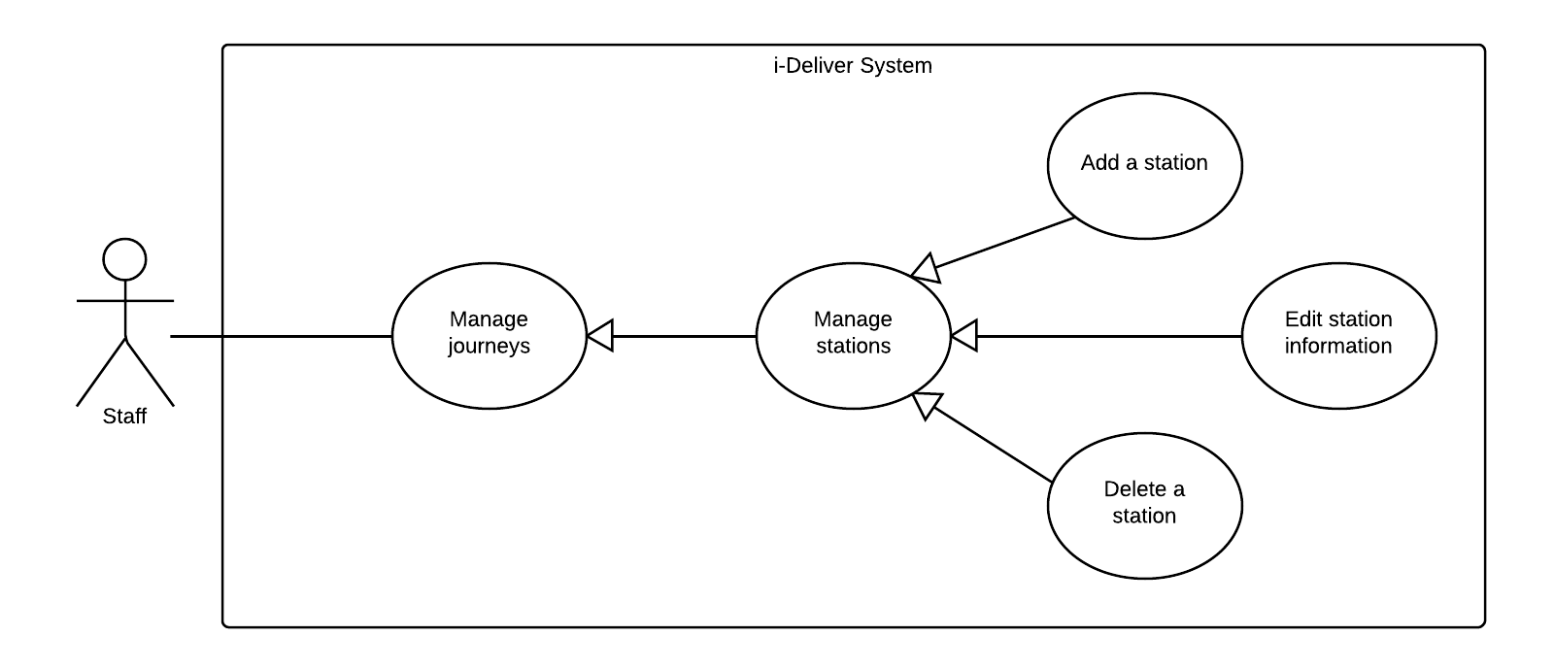

|  |  |  |  |  |
| --- | --- | --- | --- | --- |
| **ADD A STATION – SPECIFICATION** | | | | |
| **Use-case No.** | UC032 | **Use-case Version** | | 1.0 |
| **Use-case Name** | Add new station | | | |
| **Author** | LongDB | | | |
| **Date** | 10/02/2014 | **Priority** | Normal | |
| **Actor:**  *Staff*  **Summary:**  …  **Goal:**  To manually open a new station in the i-Deliver system  **Triggers:**  The user clicks on the button “Thêm một trạm mới” on the station management page.  **Preconditions:**  The user is already logged in with an account of Staff role.  **Post Conditions:**  *On success:* A new station was added to system’s database. The user is redirected to trip station page which is now has a section that describes the currently added station.  *On failure:* An error message is displayed. Please refer to the Exception Scenario section the see what the content of the error message is.  **Main Success Scenario:**   |  |  |  | | --- | --- | --- | | **Step** | **User Action** | **System Response** | | 1. | Clicks on the button “Tạo trạm chuyến mới”. |  | | 2. |  |  | | 3. | Fills out the form with relevant values.  [See Exception No. 1, 2, 3, 4, 5, 6, 7, 8, 9, 10, 11, 12, 13] |  | | 4. | Clicks the button “Lưu và quản về trang quản lý”.  [See Alternative No. 1, 2] |  | | 5. |  | Saves the stations to the database and redirects the user to the station list page which now has a new section that describes the newly added station.  [See Exception No. 14] |   **Alternative Scenario:**   |  |  |  |  | | --- | --- | --- | --- | | **No** | **Step** | **User Action** | **System Response** | | 1. | 1. | Clicks on the button “Quay về trang quản lý”. |  | | 2. |  | Shows a popup to ask the user to confirm the action. | | 2. | 1. | The user chooses “OK”. |  | | 2. |  | If the user confirms to go back, redirects the user to the list page, otherwise, just hide the popup. | | 3. | 1. | Clicks on the button “Lưu và tiếp tục”. |  | | 2. |  | Saves the station to the database and redirects the user to the station list page. |   **Exceptions:**   |  |  |  | | --- | --- | --- | | **No** | **User Action** | **System Response** | | 1. |  |  | | 2. |  |  | | 3. |  |  | | 4. |  |  | | 5. |  |  | | 6. |  |  | | 7. |  |  | | 8. |  |  |   **Relationships:**  “…” use case  **Business Rules:**   |  |  | | --- | --- | | **No** | **Business Rule Description** | | 1. |  | | 2. |  | | 3. |  | | | | | |

#### « Staff » Edit station information



|  |  |  |  |  |
| --- | --- | --- | --- | --- |
| **EDIT STATION INFORMATION – SPECIFICATION** | | | | |
| **Use-case No.** | UC033 | **Use-case Version** | | 1.0 |
| **Use-case Name** | Edit station information | | | |
| **Author** | LongDB | | | |
| **Date** | 10/02/2014 | **Priority** | Normal | |
| **Actor:**  *Staff*  **Summary:**  This use case allows a staff to view and manually change information about an existing station in the database.  **Goal:**  To manually edit information of a station in the system.  **Triggers:**  The user clicks on the button “Thông tin trạm” on station management page.  **Preconditions:**  The user is already logged in with an account of Staff role.  The station management page is being displayed.  **Post Conditions:**  *On success:* The information of selected station is updated in the system. The user is redirect to the station management page where information is currently updated.  *On failure:* An error message is displayed. The content of the error message will be specified in the Exception Scenario section based on the type of failure.  **Main Success Scenario:**   |  |  |  | | --- | --- | --- | | **Step** | **User Action** | **System Response** | | 1. |  |  | | 2. |  |  | | 3. |  |  | | 4. |  |  | | 5. |  |  | | 6. |  |  |   **Alternative Scenario:**   |  |  |  |  | | --- | --- | --- | --- | | **No** | **Step** | **User Action** | **System Response** | | 1. | 1. |  |  | | 2. |  |  | | 2. | 1. |  |  | | 2. |  |  | | 3. | 1. |  |  | | 2. |  |  | | 3. | 1. |  |  | | 2. |  |  | | 4. | 1. |  |  | | 2. |  |  |   **Exceptions:**   |  |  |  | | --- | --- | --- | | **No** | **User Action** | **System Response** | | 1. |  |  | | 2. |  |  | | 3. |  |  | | 4. |  |  | | 5. |  |  | | 6. |  |  | | 7. |  |  | | 8. |  |  |   **Relationships:**  “Add a station” use case  **Business Rules:**   |  |  | | --- | --- | | **No** | **Business Rule Description** | | 1. |  | | 2. |  | | 3. |  | | | | | |

#### « Staff » Delete a station



|  |  |  |  |  |
| --- | --- | --- | --- | --- |
| **DELETE A STATION – SPECIFICATION** | | | | |
| **Use-case No.** | UC034 | **Use-case Version** | | 1.0 |
| **Use-case Name** | Delete a station | | | |
| **Author** | LongDB | | | |
| **Date** | 10/02/2014 | **Priority** | Normal | |
| **Actor:**  *Staff*  **Summary:**  This use case allows a staff to remove an existing station from the system.  **Goal:**  To manually remove an existing station from the system.  **Triggers:**  The staff clicks on the button “Xóa trạm” on the section that contains the station to be deleted in the station management page.  **Preconditions:**  The user is already logged in with an account of Staff role.  The station management page is being displayed.  The station to be deleted is being selected.  **Post Conditions:**  *On success:* The selected station is deleted from the system databse. The row that contains the selected station is removed from the station list page.  *On failure:* An error message is displayed. The content of the error message will be specified in the Exception Scenario section based on the type of failure.  **Main Success Scenario:**   |  |  |  | | --- | --- | --- | | **Step** | **User Action** | **System Response** | | 1. | Clicks on the button “Xóa” on the row that contains the trip to be deleted. |  | | 2. |  | [See Exception No. 1]  Shows a popup to ask the staff to confirm the action. | | 3. | Chooses “OK” to continue to delete the station.  [See Alternative No. 1] | Marks the selected station as deleted in the database.  Removes the row that contains the selected trip from the station list page.  [See Exception No. 2, 3] |   **Alternative Scenario:**   |  |  |  |  | | --- | --- | --- | --- | | **No** | **Step** | **User Action** | **System Response** | | 1. | 1. | Clicks on the button “Hủy bỏ”. |  | | 2. |  | Hides the popup message box. |   **Exceptions:**   |  |  |  | | --- | --- | --- | | **No** | **User Action** | **System Response** | | 1. |  |  | | 2. |  |  | | 3. |  |  | | 4. |  |  | | 5. |  |  | | 6. |  |  | | 7. |  |  | | 8. |  |  |   **Relationships:**  “Add a station” use case  **Business Rules:**   |  |  | | --- | --- | | **No** | **Business Rule Description** | | 1. |  | | 2. |  | | 3. |  | | | | | |

#### « Staff » Add a route

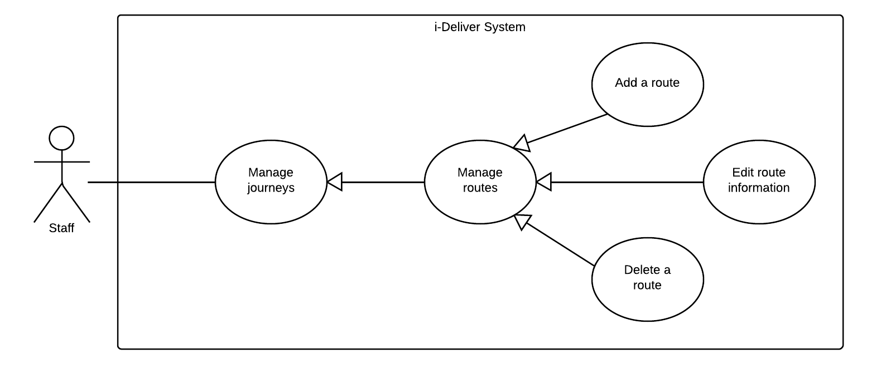

|  |  |  |  |  |
| --- | --- | --- | --- | --- |
| **ADD A ROUTE – SPECIFICATION** | | | | |
| **Use-case No.** | UC035 | **Use-case Version** | | 1.0 |
| **Use-case Name** | Add new route | | | |
| **Author** | LongDB | | | |
| **Date** | 10/02/2014 | **Priority** | Normal | |
| **Actor:**  *Staff*  **Summary:**  …  **Goal:**  To manually open a new route in the i-Deliver system  **Triggers:**  The user clicks on the button “Thêm một tuyến mới” on the routes management page.  **Preconditions:**  The user is already logged in with an account of Staff role.  **Post Conditions:**  *On success:* A new route was added to system’s database. The user is redirected to route station page which is now has a section that describes the currently added station.  *On failure:* An error message is displayed. Please refer to the Exception Scenario section the see what the content of the error message is.  **Main Success Scenario:**   |  |  |  | | --- | --- | --- | | **Step** | **User Action** | **System Response** | | 1. | Clicks on the button “Tạo một tuyến mới”. |  | | 2. |  |  | | 3. | Fills out the form with relevant values.  [See Exception No. 1, 2, 3, 4, 5, 6, 7, 8, 9, 10, 11, 12, 13] |  | | 4. | Clicks the button “Lưu và quản về trang quản lý”.  [See Alternative No. 1, 2] |  | | 5. |  | Saves the routes to the database and redirects the user to the route list page which now has a new section that describes the newly added route.  [See Exception No. 14] |   **Alternative Scenario:**   |  |  |  |  | | --- | --- | --- | --- | | **No** | **Step** | **User Action** | **System Response** | | 1. | 1. | Clicks on the button “Quay về trang quản lý”. |  | | 2. |  | Shows a popup to ask the user to confirm the action. | | 2. | 1. | The user chooses “OK”. |  | | 2. |  | If the user confirms to go back, redirects the user to the list page, otherwise, just hide the popup. | | 3. | 1. | Clicks on the button “Lưu và tiếp tục”. |  | | 2. |  | Saves the route to the database and redirects the user to the route list page. |   **Exceptions:**   |  |  |  | | --- | --- | --- | | **No** | **User Action** | **System Response** | | 1. |  |  | | 2. |  |  | | 3. |  |  | | 4. |  |  | | 5. |  |  | | 6. |  |  | | 7. |  |  | | 8. |  |  |   **Relationships:**  “…” use case  **Business Rules:**   |  |  | | --- | --- | | **No** | **Business Rule Description** | | 1. |  | | 2. |  | | 3. |  | | | | | |

#### « Staff » Edit route information



|  |  |  |  |  |
| --- | --- | --- | --- | --- |
| **EDIT ROUTE INFORMATION – SPECIFICATION** | | | | |
| **Use-case No.** | UC036 | **Use-case Version** | | 1.0 |
| **Use-case Name** | Edit route information | | | |
| **Author** | LongDB | | | |
| **Date** | 10/02/2014 | **Priority** | Normal | |
| **Actor:**  *Staff*  **Summary:**  This use case allows a staff to view and manually change information about an existing route in the database.  **Goal:**  To manually edit information of an existing route in the system.  **Triggers:**  The user clicks on the button “Thông tin tuyến” on route management page.  **Preconditions:**  The user is already logged in with an account of Staff role.  The route management page is being displayed.  **Post Conditions:**  *On success:* The information of selected route is updated in the system. The user is redirect to the route management page where information is currently updated.  *On failure:* An error message is displayed. The content of the error message will be specified in the Exception Scenario section based on the type of failure.  **Main Success Scenario:**   |  |  |  | | --- | --- | --- | | **Step** | **User Action** | **System Response** | | 1. |  |  | | 2. |  |  | | 3. |  |  | | 4. |  |  | | 5. |  |  | | 6. |  |  |   **Alternative Scenario:**   |  |  |  |  | | --- | --- | --- | --- | | **No** | **Step** | **User Action** | **System Response** | | 1. | 1. |  |  | | 2. |  |  | | 2. | 1. |  |  | | 2. |  |  | | 3. | 1. |  |  | | 2. |  |  | | 3. | 1. |  |  | | 2. |  |  | | 4. | 1. |  |  | | 2. |  |  |   **Exceptions:**   |  |  |  | | --- | --- | --- | | **No** | **User Action** | **System Response** | | 1. |  |  | | 2. |  |  | | 3. |  |  | | 4. |  |  | | 5. |  |  | | 6. |  |  | | 7. |  |  | | 8. |  |  |   **Relationships:**  “Add a route” use case  **Business Rules:**   |  |  | | --- | --- | | **No** | **Business Rule Description** | | 1. |  | | 2. |  | | 3. |  | | | | | |

#### « Staff » Delete a route



|  |  |  |  |  |
| --- | --- | --- | --- | --- |
| **DELETE A ROUTE – SPECIFICATION** | | | | |
| **Use-case No.** | UC037 | **Use-case Version** | | 1.0 |
| **Use-case Name** | Delete a route | | | |
| **Author** | LongDB | | | |
| **Date** | 10/02/2014 | **Priority** | Normal | |
| **Actor:**  *Staff*  **Summary:**  This use case allows a staff to remove an existing route from the system.  **Goal:**  To manually remove an existing route from the system.  **Triggers:**  The staff clicks on the button “Xóa tuyến” on the section that contains the route to be deleted in the route management page.  **Preconditions:**  The user is already logged in with an account of Staff role.  The route management page is being displayed.  The route to be deleted is being selected.  **Post Conditions:**  *On success:* The selected route is deleted from the system databse. The row that contains the selected route is removed from the route list page.  *On failure:* An error message is displayed. The content of the error message will be specified in the Exception Scenario section based on the type of failure.  **Main Success Scenario:**   |  |  |  | | --- | --- | --- | | **Step** | **User Action** | **System Response** | | 1. | Clicks on the button “Xóa” on the row that contains the trip to be deleted. |  | | 2. |  | [See Exception No. 1]  Shows a popup to ask the staff to confirm the action. | | 3. | Chooses “OK” to continue to delete the route.  [See Alternative No. 1] | Marks the selected route as deleted in the database.  Removes the row that contains the selected route from the route page.  [See Exception No. 2, 3] |   **Alternative Scenario:**   |  |  |  |  | | --- | --- | --- | --- | | **No** | **Step** | **User Action** | **System Response** | | 1. | 1. | Clicks on the button “Hủy bỏ”. |  | | 2. |  | Hides the popup message box. |   **Exceptions:**   |  |  |  | | --- | --- | --- | | **No** | **User Action** | **System Response** | | 1. |  |  | | 2. |  |  | | 3. |  |  | | 4. |  |  | | 5. |  |  | | 6. |  |  | | 7. |  |  | | 8. |  |  |   **Relationships:**  “Add a route” use case  **Business Rules:**   |  |  | | --- | --- | | **No** | **Business Rule Description** | | 1. |  | | 2. |  | | 3. |  | | | | | |

#### « Staff » Add new coach

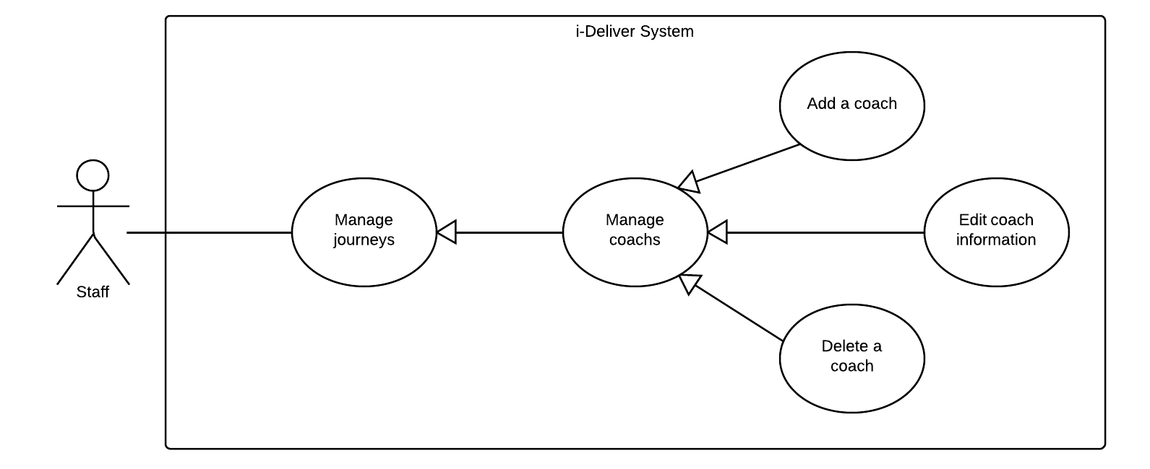

|  |  |  |  |  |
| --- | --- | --- | --- | --- |
| **ADD A COACH – SPECIFICATION** | | | | |
| **Use-case No.** | UC038 | **Use-case Version** | | 1.0 |
| **Use-case Name** | Add new coach | | | |
| **Author** | LongDB | | | |
| **Date** | 10/02/2014 | **Priority** | Normal | |
| **Actor:**  *Staff*  **Summary:**  …  **Goal:**  To manually add a new coach to the i-Deliver system  **Triggers:**  The user clicks on the button “Thêm một xe mới” on the coach management page.  **Preconditions:**  The user is already logged in with an account of Staff role.  **Post Conditions:**  *On success:* A new coach was added to system’s database. The user is redirected to coach station page which is now has a section that describes the currently added coach.  *On failure:* An error message is displayed. Please refer to the Exception Scenario section the see what the content of the error message is.  **Main Success Scenario:**   |  |  |  | | --- | --- | --- | | **Step** | **User Action** | **System Response** | | 1. | Clicks on the button “Thêm một xe mới”. |  | | 2. |  |  | | 3. | Fills out the form with relevant values.  [See Exception No. 1, 2, 3, 4, 5, 6, 7, 8, 9, 10, 11, 12, 13] |  | | 4. | Clicks the button “Lưu và quản về trang quản lý”.  [See Alternative No. 1, 2] |  | | 5. |  | Saves the coach s to the database and redirects the user to the coach list page which now has a new section that describes the newly added coach.  [See Exception No. 14] |   **Alternative Scenario:**   |  |  |  |  | | --- | --- | --- | --- | | **No** | **Step** | **User Action** | **System Response** | | 1. | 1. | Clicks on the button “Quay về trang quản lý”. |  | | 2. |  | Shows a popup to ask the user to confirm the action. | | 2. | 1. | The user chooses “OK”. |  | | 2. |  | If the user confirms to go back, redirects the user to the list page, otherwise, just hide the popup. | | 3. | 1. | Clicks on the button “Lưu và tiếp tục”. |  | | 2. |  | Saves the coach to the database and redirects the user to the coach list page. |   **Exceptions:**   |  |  |  | | --- | --- | --- | | **No** | **User Action** | **System Response** | | 1. |  |  | | 2. |  |  | | 3. |  |  | | 4. |  |  | | 5. |  |  | | 6. |  |  | | 7. |  |  | | 8. |  |  |   **Relationships:**  “…” use case  **Business Rules:**   |  |  | | --- | --- | | **No** | **Business Rule Description** | | 1. |  | | 2. |  | | 3. |  | | | | | |

#### « Staff » Edit coach information



|  |  |  |  |  |
| --- | --- | --- | --- | --- |
| **EDIT COACH INFORMATION – SPECIFICATION** | | | | |
| **Use-case No.** | UC039 | **Use-case Version** | | 1.0 |
| **Use-case Name** | Edit coach information | | | |
| **Author** | LongDB | | | |
| **Date** | 10/02/2014 | **Priority** | Normal | |
| **Actor:**  *Staff*  **Summary:**  This use case allows a staff to view and manually change information about an existing coach in the database.  **Goal:**  To manually edit information of an existing coach in the system.  **Triggers:**  The user clicks on the button “Thông tin xe” on coach management page.  **Preconditions:**  The user is already logged in with an account of Staff role.  The coach management page is being displayed.  **Post Conditions:**  *On success:* The information of selected coach is updated in the system. The user is redirect to the coach management page where information is currently updated.  *On failure:* An error message is displayed. The content of the error message will be specified in the Exception Scenario section based on the type of failure.  **Main Success Scenario:**   |  |  |  | | --- | --- | --- | | **Step** | **User Action** | **System Response** | | 1. |  |  | | 2. |  |  | | 3. |  |  | | 4. |  |  | | 5. |  |  | | 6. |  |  |   **Alternative Scenario:**   |  |  |  |  | | --- | --- | --- | --- | | **No** | **Step** | **User Action** | **System Response** | | 1. | 1. |  |  | | 2. |  |  | | 2. | 1. |  |  | | 2. |  |  | | 3. | 1. |  |  | | 2. |  |  | | 3. | 1. |  |  | | 2. |  |  | | 4. | 1. |  |  | | 2. |  |  |   **Exceptions:**   |  |  |  | | --- | --- | --- | | **No** | **User Action** | **System Response** | | 1. |  |  | | 2. |  |  | | 3. |  |  | | 4. |  |  | | 5. |  |  | | 6. |  |  | | 7. |  |  | | 8. |  |  |   **Relationships:**  “Add a coach” use case  **Business Rules:**   |  |  | | --- | --- | | **No** | **Business Rule Description** | | 1. |  | | 2. |  | | 3. |  | | | | | |

#### « Staff » Delete a coach



|  |  |  |  |  |
| --- | --- | --- | --- | --- |
| **DELETE A COACH – SPECIFICATION** | | | | |
| **Use-case No.** | UC040 | **Use-case Version** | | 1.0 |
| **Use-case Name** | Delete a coach | | | |
| **Author** | LongDB | | | |
| **Date** | 10/02/2014 | **Priority** | Normal | |
| **Actor:**  *Staff*  **Summary:**  This use case allows a staff to remove an existing coach from the system.  **Goal:**  To manually remove an existing coach from the system.  **Triggers:**  The staff clicks on the button “Xóa xe này” on the section that contains the coach to be deleted in the coach management page.  **Preconditions:**  The user is already logged in with an account of Staff role.  The coach management page is being displayed.  The coach to be deleted is being selected.  **Post Conditions:**  *On success:* The selected coach is deleted from the system databse. The row that contains the selected coach is removed from the coach list page.  *On failure:* An error message is displayed. The content of the error message will be specified in the Exception Scenario section based on the type of failure.  **Main Success Scenario:**   |  |  |  | | --- | --- | --- | | **Step** | **User Action** | **System Response** | | 1. | Clicks on the button “Xóa” on the row that contains the trip to be deleted. |  | | 2. |  | [See Exception No. 1]  Shows a popup to ask the staff to confirm the action. | | 3. | Chooses “OK” to continue to delete the coach.  [See Alternative No. 1] | Marks the selected coach as deleted in the database.  Removes the row that contains the selected coach from the coach list page.  [See Exception No. 2, 3] |   **Alternative Scenario:**   |  |  |  |  | | --- | --- | --- | --- | | **No** | **Step** | **User Action** | **System Response** | | 1. | 1. | Clicks on the button “Hủy bỏ”. |  | | 2. |  | Hides the popup message box. |   **Exceptions:**   |  |  |  | | --- | --- | --- | | **No** | **User Action** | **System Response** | | 1. |  |  | | 2. |  |  | | 3. |  |  | | 4. |  |  | | 5. |  |  | | 6. |  |  | | 7. |  |  | | 8. |  |  |   **Relationships:**  “Add a coach” use case  **Business Rules:**   |  |  | | --- | --- | | **No** | **Business Rule Description** | | 1. |  | | 2. |  | | 3. |  | | | | | |

#### « Staff » Delete Comment



|  |  |  |  |  |
| --- | --- | --- | --- | --- |
| **DELETE COMMENT – SPECIFICATION** | | | | |
| **Use-case No.** | UC041 | **Use-case Version** | | 1.0 |
| **Use-case Name** | Delete comment | | | |
| **Author** | Lê Phúc Lữ | | | |
| **Date** | 09/02/2014 | **Priority** | Normal | |
| **Actor:** Staff.  **Summary:**  This use case allows staff physical delete the illegal comment for the route, i.e., use the word are not bright meaning, advertise for external service, …  **Goal:**  Delete the specific comment of customer for route.  **Triggers:**  The staff can delete the comment that violates the rule.  **Preconditions:**  Staff enters to the manage feedback page of the system and choose the comment of route for delete.  **Post Conditions:**  *On success:* The comment will be deleted successfully.  *On failure:* The comment won’t be deleted as expected.  **Main Success Scenario:**   |  |  |  | | --- | --- | --- | | **Step** | **User Action** | **System Response** | | 1. | Staff chooses the comment of route and clicks the button “Xóa nhận xét”. |  | | 2. |  | Shows a popup to confirm the action that the staff really wants to delete the comment. “Bạn có thực sự muốn xóa nhận xét này không?” | | 3. | If staff clicks to “Yes” button. |  | | 4. |  | The comment will be deleted. | | 5. | If staff clicks to “No” button. |  | | 6. |  | Closes the popup and doesn’t do anything. |   **Alternative Scenario:**  N/A.  **Exceptions:**   |  |  |  | | --- | --- | --- | | **No** | **User Action** | **System Response** | | 1. | Staff chooses the comment of route and clicks the button “Xóa nhận xét”. When the popup showed, he/she clicks to “Yes” button to confirm. | The comment is not deleted. | | 2. | Staff chooses the list of route that he/she want to reset the rating, then click to button “Clear”. When the popup showed, he/she clicks to “No” button to confirm. | The comment is deleted or the content of it changed. | | 3. | Staff chooses the comment of route and clicks the button “Xóa nhận xét”. | The popup is not showed. |   **Relationships:**  “Comment” use case.  **Business Rules:**   |  |  | | --- | --- | | **No** | **Business Rule Description** | | 1. | The comment is legal if its content is clear and point to the quality of service, not chat, advertise, … The staff has to read the content of comment carefully to make sure not delete legal comment. | | | | | |

### Software System Attributes



#### Reliability

Information about hotels are collected via web services in such a way that preserves the most accurate and up-to-date data. There should be a mechanism that helps prevent violating referential constraints and data integrity when the system synchronizes the data from the web services.

#### Availability

N/A

#### Security

Authentication is required when the user utilizes certain functions in the system. Passwords must be encrypted so the even they are unrecognizable to even system Administrators and database Administrators. The system should also require authorization when the user tries to access an unauthorized function.

#### Maintainability

In the architecture design of the system, the responsibilities of all components should be clear and do no overlap each other.

The communications with a web service provider should be packaged in a single module independent from the rest of the system. The module should support plug-and-play, so that, when the web service provider change the structure of the web service results, or when the system must work with another web service provider, minimal changes to the rest of the system are required.

#### Portability

On the client side, the website should be accessible to anyone with a personal computer that connects to the Internet and has a browser.

#### Performance

N/A

## Entity Relationship Diagram

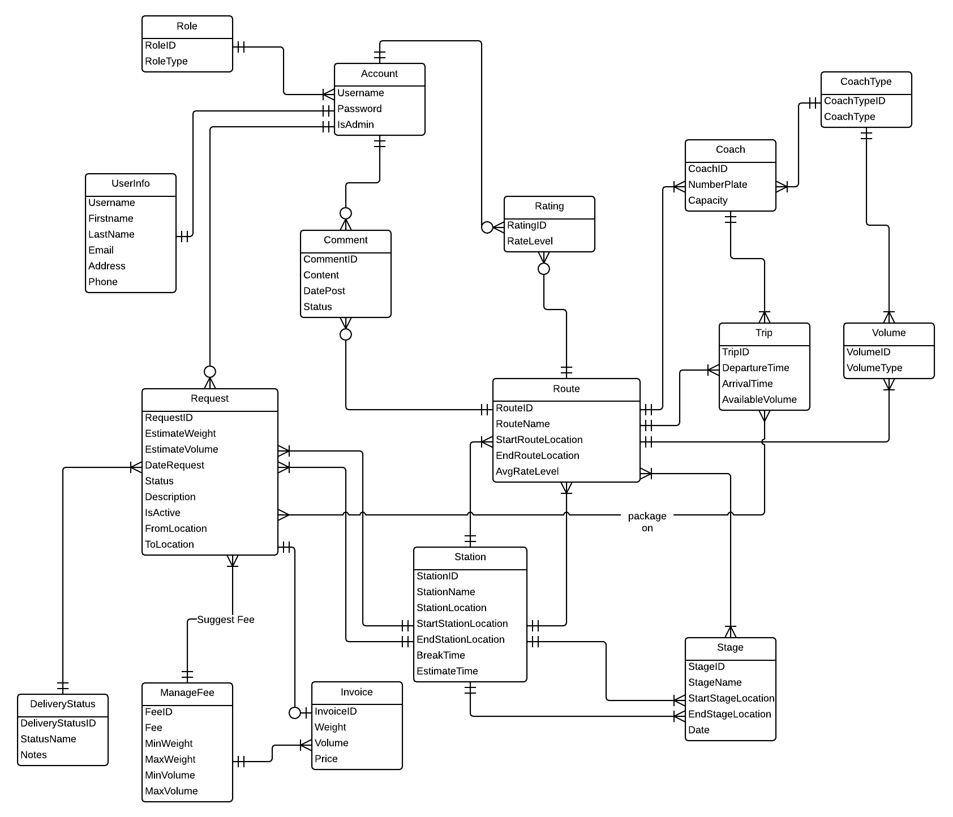

Diagram . Entity relationship diagram